**Heat Pump Dryer Design Guide**

By David Beers

In partial fulfillment of the requirements for certification as a Black Belt in General Electric Appliances

This design guide is intended as a primer in the operation and performance of a clothes dryer whose primary drying effect is provided by a vapor compression heat pump. It provides sufficient background to be instructive to the novice while offering sufficient summary format to be efficient to the experienced engineer in either clothes drying generally or the sealed systems engineer moving into clothes care.

Forward 2

Section 1 Performance 3

Section 2 Load 9

Section 3 Cloth and Lint 22

Section 4 Physics of Clothes Drying 37

Section 5 The Air 48

Section 6 Heat Engine 67

Section 7 Construction and Accessories not yet included

Section 8 Additional Features not yet included

Appendices:

Appendix 1 Nomenclature 82 in progress

Appendix 2 Glossary 83 in progress

Appendix 3 Charts and Graphs 84

Appendix 4 Thermodynamic Properties 88

Appendix 5 Psychrometric Properties 92

Appendix 6 Heat Pump Dryer Simulation 95

Stage 1 Simulation 95

Stage 2 Simulation in progress

Stage 3 Simulation in progress

Appendix 7 Compressors 112

**Forward**

This design guide is offered as a guide not a manual in learning the basic principles and methods used in the technical engineering of the heat pump dryer. It is expected that innovation will bring about improvement not only in the performance of heat pump dryers but also the methods and understanding of the principles used in heat pump dryer engineering. These improvements should be included in the Guide by regular update and editing of the guide.

The guide is not sacred. There may be errors. The regular use and review of the content may identify many such errors. I simply apologize and recommend immediate correction by the current custodian of the document.

**Form**

The guide uses an editing form often used in basic texts and technical manuals. The presentation is also taught in study methods courses as a useful format for note taking.

The page is divided into two sections by a line down the middle. General text or running notes are taken in one of the columns. Significant facts, key points and conclusions on review are recorded in the second column. The second column is generally much sparse but contains the high importance information in summary form.

**Using the Guide**

The experienced engineer will want to focus on the Summary or “Essentials” column for quick reference to key formulae, summary of principles, process steps or design step objectives.

The less experienced engineer may want to start with the “Background” column for the development of the principles and work toward the “Essentials” column when understood.

Any user can actually start anywhere and by regular study master the engineering of the heat pump dryer in fairly short order.

Section 1 – Performance

Performance has to do with the desired behavior of the appliance under certain environmental and load conditions that its owners place upon it. Performance includes both the consumer desired performance and the regulated performance required by government and rating agencies. This section explains the raw performance indicators and the compound indicators used to express performance in meaningful ways.

|  |  |
| --- | --- |
| Essentials | Background |
| Wet conditions  IMCSLOW SPIN ≈ 70%  IMCDOE = 53%  Dry conditions  FMC = 3-5%  FMCDOE = 4% | In considering drying performance the fundamental definition serving as the referee of all drying performance is the moisture content   1. Moisture content   And there are two basic parameters of performance for a dryer:   1. Time to dry 2. Energy to dry   All other parameters are derivative, or feature related, therefore unrelated to engineered performance. However, performance of certain features will be discussed in a section entitled “Additional Features” later in the guide.  **Moisture Content**  The referee measurement for all discussion of drying performance is moisture content.    The moisture content is the ratio of “wet” weight minus dry weight divided by dry weight.  This ratio is used to express throughout dryer testing the condition of the cloth being dried. Two special cases are usually defined to represent the two end points of a test.  The moisture content at the beginning of a test is written as the initial moisture content, or:    And at the end of a test as the “final” moisture content:    If a test is terminated at any time before a dry condition is reached, or any time before terminated by a normally controlled “dry” condition is reached we call the condition a “residual” moisture content or:    In this final case the “wet” condition is the weight of wet cloth at the end of the test or at the time the test was terminated.  **Time to Dry**  The consumer has many expectations of a clothes dryer. The foremost is that the dryer follows the washer in processing the clothes cleaning work flow. First the wash, then the dry. The work flow flows best if the consumer can always unload wash into the dryer. The flow is interrupted if the washer cannot be unloaded directly into the dryer.  Time to dry then is the consumer’s metric. While it has a finite time for a given load it is always judged by the consumer relative to the wash cycle time. That is, when the washer takes 1 hour to wash the clothes from load to unload, then as long as the dryer takes less time to dry the dryer is “fast enough”. Stated differently, if the dryer is not done when the next wash load is completed the dryer is “too slow!”  The consumer usually does not judge numerically; but by the facilitation or interruption of flow.  However this document is a design guide for engineers.  Engineers satisfy consumers by delivering performance. All performance is measured numerically. The trick with product engineering is to deliver performance that is always “fast enough” for the consumer, but measured in seconds, minutes, or hours.  Since the acceptable reference is the washer and the length of the wash cycle, then the time of the wash cycle can be used as the reference or specification for dryer performance.  The initial time used for R&D to demonstrate Heat Pump Dryer performance was that an 8 pound towel load takes about an hour to complete a wash cycle.  There is one additional input provided by the washer. That is the initial cloth condition at the completion of the wash cycle after rinse and spin.  Conventional vertical axis washers usually deliver cloth with remaining moisture equal to about 70% of the dry weight of the cloth. So, if one starts to wash 8 pounds of cloth (assumed to be dry) the engineer can expect the cloth presented to the dryer to be about 8 pounds of cloth plus 8 X 0.70 = 5.6 pounds of water. The total weight presented to the dryer is then 13.6 pounds.  Coincidentally, the DOE standard for dryer performance factor testing also assumes dryer loads starting at 70% IMC  Modern horizontal axis machines spin at much higher speeds and therefore final spin leaves the cloth with much lower moisture content. Some as low as 45% residual moisture for the wash cycle. Newer vertical axis washing machines are also reaching residual moisture content near 53%.  Cloth is usually considered “dry” by consumers at about 5% residual moisture. DOE calls for the performance testing to consider 4% RMC for the “dry” condition.  For R&D purposes we have considered the time-to-dry (TTD) to mean the time to proceed from the IMC to the FMC or final moisture content. We have selected the DOE RMC = 4% to be the FMC for the “dry condition.  For engineering purposes and the sake of repeatable experimentation we have adopted another metric, Residual Moisture Content (RMC) at constant cycle length. Cloth is usually considered “dry” at an RMC of 5% or less. The DOE standard is 4%.  Since most wash cycles take 1 hour, then 1 hour is used as the standard test cycle. The ideal of performance is that all test loads would reach 5% or less in the allotted 1 hour.  A load is placed in the dryer that uses most of the allotted cycle time in a reference current electric dryer.  The cloth of choice for developmental testing is cotton towels, 8 lbs dry weight. This load size has been selected because it takes most of the target one hour to dry, cotton towels are the hardest cloth to dry and they generate the most lint as a complication to drying.  **Energy to Dry**  The energy consumed in drying is the principle qualifier to sell the product. While consumers care little for the energy consumed, being reasonably transparent in actual operation, the selling environment is making it more and more a public concern with visible point of sale communication.  There are two expressions of energy to dry:   1. Energy Factor 2. COP   **Energy Factor**  Energy Factor is the DOE’s expression of drying energy performance. It is the ratio of lbs of dry cloth dried divided by kilowatts of energy consumed from a specified initial water content to a specified final water content  Current DOE standards call for EF’s of 4.3 or higher. Competition is achieving energy factors of 5.3 with heat pump technology. We have seen energy factors of 6 regularly with energy testing of our own prototypes. It is observed in testing at Oak Ridge National Laboratory (ORNL) without auxiliary heating energy factors as high as 7.1 with dry time of 65 minutes.  **COP**  COP or coefficient of performance is defined as the ratio of desired effect to the energy to produce that effect.  In the case of clothes drying the desired effect is the transformation of water to steam so that it can be carried away. Thus if 1 lbm of water is desired to be removed, then the latent heat of vaporization is 970.3 Btu or 287.2 watt∙hrs.  Now it is easily recognized that if the sensible heat is included in the calculation that the resulting COP will be higher. However, the sensible heat does not contribute to the desired effect since sensible heat merely raises temperature but does not change phase. If phase is not changed, or if water remains liquid in the cloth, then the water cannot be moved and no beneficial effect has been realized. So even though all the energy, latent and sensible is included in the denominator, only the latent is included in the numerator.  When calculated in consistent units, that is Watts/Watts, the COP feels like an efficiency which is satisfactory to an engineer. It tells the engineer something about the effectiveness of the machine. Whereas the EF is most meaningful to a consumer with a load of cloth to dry. |

**Section 2 – The Load [all design grows from the load]**

The load consists of the engineering demand placed on the appliance. The load is the problem that must be resolved or the problem that is to be solved by the investment of work or energy.

**The Load**

|  |  |
| --- | --- |
| Essentials | Background |
| LoadH2O = IMC X WDRY  [where WDRY is the dry cloth weight]  HFG H2O = 970 Btu/lbm | THE LOAD There are two aspects of load that must be considered in the heat pump dryer.   1. Getting water out of the clothes. 2. Condensing the water to pump it out of the dryer.   In the conventional dryer heat is used to get the water out of the clothes and an air blower expels the resulting water vapor out the exhaust hose.  The heat pump dryer sets up a closed loop air circuit using an evaporator to extract water vapor and a condenser to reheat air and then heat the clothes.  The load is the starting point for the design. One must first understand the load or work that must be done. Then we can consider the limitations and conditions the load places on the design of the refrigeration system.  The topics to properly develop load are as follows:   |  |  |  | | --- | --- | --- | | 1 | What types of loads |  | | 2 | How much water | Energy | | 3 | How fast must it be removed | Power | | 4 | Practical power delivery | Effectiveness |  What the consumer tells us about the Load Research that goes into the QFD gives us many insights into how the consumer loads the dryer. It is up to the engineer to translate those usages and patterns into useful statements and limiting cases of design loads. In general, consumers define two ways of thinking about the product.   * How much * How fast   How much has as much to do with “how much of what” as it does with how much. The engineer must be aware that he is not permitted to limit or restrict the consumer’s use of the product. They will do what they do. We will first consider the “what” and then the “how much.” Types of Loads The types of loads are made up of a quantity of a type or mixture of types of cloth. Types of cloth are made of various weaves of natural and/or synthetic threads. The natural threads include cottons, woolens and silks. Synthetic threads are Dacron, rayon, nylon, polyester, and polypropylene. The synthetics are normally solid threads and therefore water absorption is only in the warp and weave of the fabric in the spaces between the threads and fibers or interstitial wetting. The natural fibers are full of little cavities in the basic fibers. So water take-up is not only interstitial but also internal to the fiber. Woolens, depending on the type, are full of lanolin that repels water but can still become quite wet. When water take-up is within the fiber it is more difficult to get out. This is why cotton is considered the most difficult drying load. There are 4 basic cloth types of concern:  Linens blended fabrics, synthetic and cotton, medium weight, medium weave  Delicates typically synthetic with small amounts of cottons if any, light weight, tight weave  Towels Cotton and synthetic, light weight loose weave  Denim Dense, tight, heavy Cotton Of all these cloth types, towels are considered the most extreme in terms of the load on a dryer. In addition to the load type one should consider the cycles recognized in the industry. There are five:  Easy Care blends of synthetics and cottons, permanent press and no-iron  Cottons primarily cotton cloth items  Mixed mixed blends not necessarily easy care.  Delicates finer threads and weaves including laces and sheers.  Ultra Delicate sheers and slips nylons, mechanical damage easy  Again, cottons are considered the most challenging with delicates and ultra being of concern. For a more complete discussion of cloth and clothes see Section 3, “The Cloth”. How Much Load Some customers measure load in terms of volume, others in terms of weight. Those who express load in terms of volume often use the terms washer drum or as much as I can fit in my washer or as much as I can fit in my dryer drum. Those who speak in terms of weight will often mention certain weights but have difficulty equating a load to any specific weight.  As engineers we like to make comparisons, the consumer doesn’t care about arbitrary comparisons. Their satisfaction is not determined by our arbitrary comparisons, but on how our device handles their load.  DOE considers 15 lbs a do-not-exceed for testing load. For those consumers who fill a washer until a personal discomfort level over wash quality is reached, research has shown that less than 1% of the population will load more than 20 lbs of dry cloth. At a Laundromat, 21 lbs is threshold. It is possible to cram 29.5 lbs of dry cloth into a 3.6 cuft drum. On the small side, there is probably no lower limit on load size.   Figure xx: Graphic representation of load distribution. This is not scientifically based but rather anecdotal based on verbal and written evidence.How Much Water? Water retention has several significant independent variables including cloth type, spin speed, load size. In general, towels have the greatest water retention at about 85%. The former DOE load at 7 lbs dry is considered to have 70% retention. The new 2015 load is YY lbm and 53% IMC.  The practical water load on a dryer is actually the difference between the initial water content (IWC) and the ending water content (IWC). In general the ending water content is thought of as 4% though as the load tables below show they may be differing amounts (see table 1).  The basic DOE load is 7 pounds of mixed cloth with 70% IMC and 3% FMC. This gives water removed to be:  H2O = WBD∙(IMC-FMC)  = 7∙(0.70-0.04)  = 4.62 lb H2O  Obviously, there is myriad water content depending on dry load and IMC percentage. Consider table A2 1 and chart 1 below:   Figure 1: Surface plot of water weight of loadHow Fast? The load of a dryer cycle is not independent of the washer cycle. In most cases the dry cycle immediately follows the wash cycle. Therefore whatever went into the washer is what will go into the dryer. Many consumers launder multiple loads in series. Therefore their expectation is that they will be able to have the dryer cleared when the next load of wash is complete. This expectation sets the upper limit on dry time from a consumer’s perspective. It should equally set our expectation for dry time.    Table 1: Sample loads and water removed. Note there are five basic cycles but we only test three of them. Note the IMC levels and the FMC levels which reflect the type of cloth and their tendency to hold water. This data is from an older washing machine with lower spin speeds in rinse. We may need to revisit this table with higher speed spin of modern units.  Table 1 above develops the basic test loads and cycles imposed on the dryer. Note that the times given are maximums. The performance of industry offerings is generally far quicker than the times shown. An effort will be made to capture the actual industry performance in the setting of standards given in this design guide. Certainly the following represents a minimum improvement to the above standard taking into account industry performance. Practical Power Delivery Practical power delivery is about how fast power can in fact be delivered to wet cloth. This involves empirical knowledge and efficiency as much as theoretical knowledge.  Using conventional dryer performance as an indicator and applying the definition of COP one comes to the conclusion that the conventional dryer operating at 5400 watts and 30.9 minute dry time with all the extracted water being converted by whatever means to vapor, the system is approximately 48% effective in getting the consumed energy to the clothes.  Efficiency of getting heat into the water in the cloth (sample calculations)  Using performance from the Magellan Dryer:  QSENSIBLE = MASSH2O∙CPH2O∙(T2-T1)  = lbm∙Btu/(lbm∙OF)∙OF/(Btu/Wh)  = 4.62∙(1)∙(212-55)/3.413  = 213 Watt∙hr  QLATENT = MASSH2O∙HFG H2O  = lbm∙Btu/lbm/(Btu/Wh)  = 4.62∙(970.3)/3.413  = 1,314 Watt∙hr  EFFHEAT TO H20 = ELATENT/ECONSUMED  = W∙hr/(W∙min/(min/hr))  = 1,314/(5,400∙30.9/60)  = .48 or 48% effective  Notice that both time and energy is involved in this calculation. The quotient of the two is work or energy per unit time or power.  The conclusion to be reached here is that the Magellan dryer is only about 50% capable of getting power from the electric burners to the water in the load. This must be taken into account in the load placed on the refrigeration system of the heat pump dryer. The load is not simply the product of latent heat of vaporization and amount of water divided by time to dry but also the inherent losses in converting heat energy in an air stream to effective drying in the drum.  So the key question is how effective is the heating and blower system in getting heat to the water to turn it into steam so that it can be transported out of the system. The definition of efficiency or effectiveness is the energy to produce the  Using this as a starting point, one is presented with the question, “What if the efficiency of delivering power to the water can be improved, or is different with different load types?” If this is the case, then it is useful to plot specific power or water liberation rates as a function of power delivery efficiency (Figure 1).    Figure 2: Liberation of water as a function of input power and power delivery efficiency. Power delivery efficiency is found by dividing the latent heat of vaporization times the amount of water removed from the clothes load by the nominal input power consumed  By factoring the power into the calculation an expression for vapor liberation rate is directly calculated and a family of curves in Watts and efficiency is created.  At this point it is useful to remind the reader that the water liberation side represents the net effect of heat rejected from the yet-to-be-designed refrigeration system. The total heat available is the condenser heat and the compressor heat. These two components are greater than the    Figure 3: Water vapor availability in air as a function of nominal input power and conversion efficiency. Water available is the load presented to the evaporator to be condensed and discharged from the system.  evaporation side capacity but must all be rejected for system stability.  Water vapor at a rate is now available to the evaporator via the airflow system. This water vapor must then be condensed back into liquid form to be expelled or pumped from the system.  This represents the initial design load for the system. Admittedly the high side capacity must be a little larger than the low side, but in refrigeration we normally size a system using the low side to spec the system since that is normally considered the source for heat to be moved from. Therefore, assuming that there are no system mass leaks and that all the water is vapor and therefore requires the full heat of vaporization to be condensed. It is then necessary to consider the target time to dry to determine applied capacity and back check the water liberation rate for availability. The following calculations can then be made:  Load sample calculations  QDOTCAP = MH20∙HFG∙(TTD-(1-LF))  = 5.28∙970.3(0.667(1-.5))  = 15,360 Btu/hr  = 4,501 Watts  TTD = MH2O/MDOTLIB  @: Watts = 4,000  EFF = 0.5  MDOTLIB = 4,000∙0.5∙3.413/970.3  = 7.06 lbm/hr  = 4.62 lbm/7.06 lbm/hr  = 0.652 hrs  = 39 min  Notice that the times match in the two above calculations but the Watts do not. This means that another iteration of calculations needs to be made to make the two close on one another. The MDOTLIB is calculated using effectiveness so both these calculations are already compensated for effectiveness in getting the heat to the load.  The solution can be understood graphically by the following means.  The moisture ratio is the expression used to determine the amount of water in a given load as received from the washer. In the case of a moisture ratio of 0.7 the moisture content of the total load has 70% of the dry load weight added in water. Or, that if an 8 lb load is at 70% moisture ratio the total load weight is 8 lb X 1.7 or 13.6 lbs total dryer wetted load.  At the wall we measure power consumed. Power is the time rate of work or work per unit of time. Therefore time is inherently a factor in the calculation of power consumption or heat energy per unit time necessary to dry the load. In this case it shows up in the denominator of the capacity calculation.  Finally, LOSS FACTOR bears a little discussion. Ultimately a fudge factor, it is nevertheless a significant and required element of any energy calculation where energy is transformed. In the equation it represents several non-negligible effects or elements. It should include the entropy of heat transfer, the energy that does not ultimately get to the water, the energy that does not get to the clothes and the energy that is lost by any other means. The author was given a rule of thumb many years ago that in absence of any other information to the contrary assume 30% loss for each transformation of power or energy. So in this case a 50% - 60% loss factor would be appropriate until the actual system behavior were understood better or significant energy recovery techniques applied. GLOSSARY IMC Initial Moisture Content. The weight of water ratio to weight of dry cloth at the end of the wash cycle.  FMC Final Moisture Content. The weight of water ratio to weight of dry cloth at the completion of the dry cycle. |
|  |  |

**Section 3 – The Cloth**

This section is given to lay a foundation of understanding of cloth from the physical construction of the fabric to the microstructure of fibers. This understanding is necessary to develop the quantitative explanation of the physics of drying.

|  |  |
| --- | --- |
| Essentials | Background |
|  | Cloth is an interlaced assembly of threads which are in turn twisted strands of fibers. Fibers form the essential building block of all cloth.  **Fibers**  A fiber is the essential building block of thread and cloth. Fibers come in two types, porous and solid.  The animal fibers such as wool, hairs and silk are generally solid with an outer dermis and various other layers.  Plant fibers can be both solid and tubular. Cotton in particular is tubular in nature as are other plant fibers such as flax and linen. Cotton has an outer waxy dermis that prevents water absorption and rot while on the plant. This layer is removed in processing as well as all internal liquid and solid mater which accounts for its high water take-up when wetted. Water is easily absorbed through its outer layers into the internal cavities.  **C:\Users\DAD\Documents\DADS FILES\B1 ENGINEERING\B1 2 DESIGN GUIDE\NEW DESIGN GUIDE\PICTURES\VARIOUS FIBERS LINEN COTTON WOOL SILK.bmp**  Figure ZZ: Linen Cotton Wool and Silk, all natural fibers. Cotton and wool fibers are both solid and porous. The cotton fiber is a tubular with open ends while wool is also tubular with openings all along it’s length.  Synthetic fibers are mostly solid. Made of long chain polymer extruded or drawn into continuous solid strands. Any molecule sized interstitial spaces between molecular chains must be filled by molecular solid diffusion through the plastic. Consequently, the fibers stay relatively “dry”.  Figure ZZ: Synthetic fibers are formed by extrusion or drawing processes from a pool of liquid resin. Therefore they are solid fibers  The range of water takeup by polymers is mostly described by surface wetting and water affinity. For instance Nylon has both high surface wetting and affinity with enough water absorption (diffusion) into its matrix to cause notable swelling of basic dimensions and increase in weight. Fit issues with nylon are possible from the swelling. Polypropylene on the other hand is hydrophobic and neither surface wets nor absorbs water. Polypropylene has long been a good choice for non-wetting and easily washed and dried undergarments.  By comparison all synthetic fibers are less wetable than animal or plant fibers.  **Thread and Yarn**  A thread is formed by drawing and twisting bundles of fibers until a fine thread is formed. Since all but synthetic fibers are relatively short, the bundling makes up continuous thread by “tangling” finite fibers and dragging them into the twist. The subsequent tension in the twist locks the fibers into the twist and friction between fibers determines the strength of the thread.  Yarn is formed by twisting or braiding 2 or more threads together. Since it undergoes the same forming processes as thread and looks and behaves like thread it is considered simply a large thread. But its wetting properties and capacity for water are much greater than a single thread.  C:\Users\DAD\Documents\DADS FILES\B1 ENGINEERING\B1 2 DESIGN GUIDE\NEW DESIGN GUIDE\PICTURES\COTTON THREAD.jpg  Figure 22: Cotton thread showing the tangling and twisting of fibers to create the thread body. It is easy to imagine water in all three forms in this matrix.  In the case of synthetics if the fibers are large enough, single fibers may be thread because they are continuous. If finer, they may be twisted into threads of various weights.  C:\Users\DAD\Documents\DADS FILES\B1 ENGINEERING\B1 2 DESIGN GUIDE\NEW DESIGN GUIDE\PICTURES\NYLON 1.jpg  Figure 33: Nylon strands that can be either fibers or threads depending on the draw size and desired properties of the resulting cloth. Notice it is solid. But the high hydrophilic nature allows water to diffuse into its molecular structure.  As with all solids in compressed contact, at a microscopic level contact is intermittent. Therefore between the fibers in a thread there is significant interstitial space. But the space is still small for surface tension. Depending on the surface wetting factor the fiber may hold liquid film water that completely fills the thread and provides a film on the outside of the thread.  **Cloth**  Threads or yarn, when woven make up cloth which represents another opportunity for surface tension to hold more water. By comparison the threads represent a 3D volume to take up water, cloth is a 2D surface depending on the coarseness of weave and size of thread. Certainly, if the cloth is made of heavy or bulky yarn there will be a thickness or 3D character to wetted cloth.    **Figure XX:** Matrix of cloth. The tight or fine weaves have less space for interstitial water but what water is in the matrix will be tighter bound and the mass higher for total energy to dry. The tighter weaves also make a barrier for air circulation when the cloth is approaching the dry state.  Depending on the fineness of the thread and the tightness of the weave the interstitial spaces in the cloth may be on the order of the spaces in the thread and therefore wet just like a single thread except forming a large sheet of water. If the weave is course enough the interstitial spaces may be so large as to prevent droplets from being retained as a film attached to two or more threads of the weave. In any event any film so formed between threads of the weave will have an inward meniscus or concave shape between the attached threads.  **Modeling Heat Distribution in a Wetted Mass**  From an engineering perspective, except for the synthetic fibers, the boundary of a thread is difficult to define. The surface of the twisted, irregular, and discontinuous fibers is complex. It is possible that the surface area compared to the volume occupied is very-very high. Yet such a ratio may be useful in explaining some of the wetting properties of thread and cloth.  Just as resistance to flow is modeled by hydraulic diameter it is reasonable to model surface wetting or water retention by parameters such as surface to volume ratio. Or, other factors may be used such as maximum separation distance, surface tension to mean distance ratio. Could there be an affinity ratio?  When considering the penetration of heat into the core of a wetted fabric there are a number of factors to consider:   * Relative conduction of water, air and fabric. * Relative convection coefficient to conduction coefficients (a form of thermal diffusivity). * Longitudinal, transverse and normal path lengths. * Temperature intensity.   Thread  While cloth forms a matrix for trapping droplets of moisture in its geometry the real X controlling drying is the thread. Below is a source diagram for fibers that make up thread.    Figure XX: Classification of filaments which are twisted together to make thread. Thread is then woven to make cloth  Each of the fiber types above has unique properties that modify the water interaction both as fiber, thread and cloth. The table below presents some of the unique properties of each fiber type and how it affects both thread and cloth drying.  **Natural Fibers**  Hair: Animal fibers are the product of natural processes of animal life. Hair’s natural function is insulation. Mostly composed of animal protein there are also traces of animal fats, and other compounds in the hair. The fat and other compounds affect both the wetting properties and insulation value of animal hairs.  Excretions: Another product of the animal kingdom that produces fibers that can be used for threads is excretions, generally from the insects of the planet. From worms come the filaments of cocoons that when unraveled are used to create silk. From spiders come the web material. Little used for thread because of its adhesive properties, it nevertheless can be twisted into thread and woven into fabric.  Deconstructed Plant Material: The fibrous plants such as bamboo and jute can be harvested, cut to length, pulverized and dried to be made into fibers, thread and cloth. Even corn stalks could be treated similarly. These being cellulose, they should have very high water affinity.  Cultivated Fibers: Several plants grow fibers naturally as part of their seed delivery. Whether in seeds or bols they can be harvested, separated, cleaned and then drawn and twisted into thread. The most common globally is cotton. |
|  | **The Lint [1]**  A natural by-product of clothes use and care is lint. Lint is the result of the destructive forces involved in weaving, pressing, packaging and use. All these forces combine to damage the cloth, break the threads and unravel the fibers. In addition the natural abrasion of use and the action of water and agitation soften and further break fibers up into smaller and smaller pieces.  One cannot discuss the cloth in a dryer without also dealing with the artifacts of cloth or lint.  Lint is classified in two groups, fiber and particulate. The two must be treated differently since they behave differently. Whereas fiberous lint is long and usually kinky or curly it is easily trapped by fairly course filter media. It is also easily cleaned off by simply swiping the filter media with a damp or tacky cloth or a bare hand.  Particulate lint is entirely different. Extremely short, often fluffy it is the dust of cloth. It is very difficult to trap even with the finest of filter media. In order to trap it with filter media, one must be willing to pay the price of pressure drop to trap it. Pressure drop is the enemy of air flow and may greatly increase the power of air movement or decrease the output of existing blower systems. This particulate lint that blows right through most filters is the stuff that collects at exhaust ducts and house siding for vented dryers. It builds up and collects in vent pipes becoming one source of dryer fires.  A photographic comparison is shown in figure XX. Notice the small size of the weave of the filter media.    Figure XX: Comparison on cotton lint fibers and particulate. Particulate on the right is much finer and passes through most filter media collecting instead on oily, static or rough surfaces. Fibers on the left are nearly completely captured on a fairly course cloth or filter media.  “Lint” is a very nonspecific term. For our purposes it includes fibers and fiber fragments released from clothing during the laundering cycle. It is important to note that other materials, such as paper fibers, dust, and hair may also be released into the air stream by the load. Because the air system is sealed, anything put into the unit will stay in the until unless it is removed, either with the load, with the water, or via a filtering mechanism.  Air load  Lint is a load on the air system because it can accumulate on the filter and coil and in the duct system, impeding air flow. Reduced airflow impacts both the rate of heat transfer to and from the refrigeration system and also the rate at which moisture can be absorbed from the wet clothes. See the Air System section of this document for more information.  Refrigeration load  Lint is a load on the refrigeration system directly by interfering with the heat transfer rate between the air flow and the heat exchanger coils. There are three categories of possible interaction:   1. Lint buildup on the coil that breaks up the boundary layer and ultimately increases the convective heat transfer coefficient between the air and the coil 2. Lint buildup on the coil that reduces airflow through the system and ultimately decreases the heat transfer rate between the air and the coil, 3. Lint buildup on the coil that acts as an insulating layer between the metal fins and coils and the air flow that ultimately decreases the heat transfer rate between the air and the coil.   The type or types of interaction and the severity of those interactions depends on the design of the coil and airflow, the wetted condition of the coil, and on the type and quantity of lint making it into the heat exchanger.  Specific fiber types  There are two major fiber categories—filament yarn and spun. Filament fibers are continuous strands such as silk and nylon. Because the fibers are continuous, they tend to shed very little lint and are largely irrelevant to the lint load produced by laundering. That is, the long fibers are extremely well anchored into the yarn and are not easily pulled loose from the bundle. Spun fibers are shorter fibers such as cotton. Yarn made from these fibers tends to have more loose ends, which are easily worked loose from the main yarn by the mechanical action of the laundering. This type of fiber makes up virtually all of the lint load.  Shape  Most fibers are approximately circular in cross section. Whole textile fibers pulled loose form garments tend to be long relative to their diameter and kinked (L > 20D). In the case of natural fibers, this kinking is due to the laundering process; in the case of synthetics like nylon, it is due to the nature of the weave. Their length and kinked shape cause them tend to tangle and matt, making these fibers relatively easy to filter by mechanical means.  Density  The density of lint is difficult to estimate. The density of the actual fiber mass is relatively high (comparable to water for most materials), but the morphology of the fiber means that the effective density can vary considerably in the case of conventional lint. Cotton, for example, is hollow, so the density of a dry strand is much closer to the density of air than that of pure cotton mass. Additionally, cotton tends to cling together, so the effective density of a fiber mat is even closer to that of air. On the other hand, a wet cotton fiber may be filled with water and has a density not appreciably different from that of water.  For fine lint, the density of the actual fiber fragments is close to that of the fiber mass (comparable to water), but again their non-uniform shapes and clumping behavior make an estimate of true density very difficult and not very useful.  Reynolds Number  A more telling descriptor of lint behavior in air is the Reynolds number, a measure of the ratio of inertial forces to viscous forces.    It is clear that viscous forces dominate. This is because of the extremely small characteristic length of both conventional and fine lint, augmented by the relatively low density of air. Even though the viscosity of air isn’t particularly large, it isn’t nearly low enough to compensate for the small length scale.  Dominant viscous forces mean that the lint tends to be dragged along with the air in its immediate vicinity. The flow of the air through the ductwork may be very turbulent, but the flow of the air relative to the immersed fiber is laminar in the extreme.  This leads to a very low terminal velocity. Thus, the fiber may be slowly falling through the air, but the block of air through which it is falling is itself traveling upward due to the turbulent flow through the ductwork and the net velocity is upward.    This Reynolds number also virtually rules out inertial separation methods. In a basic inertial separator, the fluid stream with entrained particles impinges on a surface. The fluid, with relatively little inertia, makes the turn while the particles, with greater inertia, are stuck on the surface. With a very low Reynolds number, the particles are dragged along with the turning fluid by the high viscous forces and remain entrained in the flow. Even though their inertia is greater than that of the fluid, the viscous forces are simply too great to allow separation.  Texture  As stated above, cotton fibers tend to kink during laundering and will readily tangle and mat with each other and with filter media. Animal fibers, such as wool, have a similar tendency to kink, as well as a scaly surface. Agitating these fibers against each other during drying is similar to backcombing or ratting human hair, making it fluff and cling to itself.  Rayon is a special case. Although technically a synthetic fiber, it is more susceptible to abrasion and will fragment like cotton. It tends to behave more like short-fiber silk than like traditional synthetics such as nylon or polyester and is found in both the filament and spun forms.  Synthetic fibers, particularly nylon and polyester, have a smooth texture. They are essentially long threads of plastic. As such, the do not readily absorb moisture and are not hollow, making their density much more consistent.  Amount  The amount of lint produced by a load depends on the load size, load type, load history, wash conditions, drying rate, and drying time. The load size relationship is obvious—the more fiber mass put into the unit, the greater the potential for some of those fibers to come loose.  Load type also has a considerable impact. Lint is made up almost exclusively of short-fiber materials, and of those cotton produces by far the most lint. A load of nylon jerseys, for example, will produce no measurable lint, while a load of cotton towels can generate as much as eight grams of lint in a single load.  Load history also plays an important factor. The yarn of brand new textiles tends to have seen very little mechanical action between its creation and its arrival at the consumer. It therefore has a large number of loose ends, many of which come loose as it cycles through the wash the first time. This quantity decreases exponentially with the number of laundering cycles, as the easy-to-remove fibers are washed away leaving only the more deeply entrenched fibers.    Figure XX: History of lint collection in wash/dry cycles from new. Much of the lint collected is generated in the manufacturing supply chain. It is collected in the first several dry cycles. Note that the generation of lint is going asymptotic in a very few cycles.  The mix of materials in the load may also affect how much lint enters the air stream. This is because some textiles attract the lint of other textiles. For example, a load consisting of half cotton and half microfiber cloths will give off much less lint than the cotton alone because the cotton lint attracted to the microfiber (both mechanically and electrostatically); you will get a relatively clean lint filter and microfiber cloths covered in lint.  Wash conditions impact the lint quantity in two ways. The first and most important is the mechanical action of the washer, which loosens fibers from the yarn, making them easier to remove or releasing them completely into the water. Not all of the released lint is washed away in the rinse cycle, and the load enters the dryer with a significant amount of lint simply laying on the surface of the fabric. As it begins to dry it is released from the damp fabric and into the air stream. The agitation, spin speed, number of rinse cycles and amount of rinse water can all play a part.  Wash conditions can also impact lint production from a chemical standpoint. Fading in dark or brightly colored garments is due in part to the yarn of the fabric beginning to fray. The short fiber ends diffuse the light, producing a duller color. Some “brightening” detergents work by chemically severing those ends, which can produce fiber fragments in and on the cloth after washing.  Fabric softeners have two competing effects. The conditioners left on the yarn may produce a slightly “sticky” effect that causes fiber fragments to cling to the cloth rather than join the air stream. On the other hand, anti-static agents in the softeners may diffuse static charge differences between the fiber fragments and yarn, releasing them into the air stream. |
|  |  |

**Section 3 – The Physics of Drying Clothes**

The load of water to be removed from the cloth is suspended into the matrix of the cloth. Depending on the cloth it is also suspended in the matrix of the threads of the cloth and perhaps absorbed into the fibers of the thread. This absorption requires up to three levels of penetration of heat and partial pressure to reach a given water molecule. It also creates up to three levels of path the excited water molecules must pass in order to reach the air where they can be carried away from the clothes.

This latter explains why it is observed that some fabrics with equal water content take much longer to dry than others.

This section of the guide will attempt to construct a theoretical base for analysis that can explain the difference in performance of drying that takes into account cloth type. It will rely on mathematical model, albeit theoretical to construct an explanation that yields approximately accurate dry times and takes into account the dimensional characteristics of cloth, temperature, humidity and air flow. The method will take into account the heat transport phenomena of convection and conduction with passing reference to radiation. It will also use the mass transport phenomenon of evaporation, diffusion and convection.

Now chemical engineers and mechanical engineers seem to have different ways of thinking about the transport phenomena. But this will strive discuss the mechanisms in terms that can be understood by all.

|  |  |
| --- | --- |
| Essentials | Background |
| Latent heat of evaporation  943 Btu/lbm  2270 kJ/kg | The first physical principles to be considered are the physical problem of water in the cloth. An artifact of the washing and spinning processes water presents in three ways. First at the molecular level, water is bonded by surface tension and potentially chemical bonding to hydrophilic objects of clothing or its fibers. Second, water is held as droplets in nucleation sites within the weave of the fabric and twist of the threads. This most often with treated or hydrophobic fabrics where wetting is resisted. Third, water is attracted into cavities of the fibers of the threads where it is held like a water balloon. In order to dry these fibers sufficient heat must be applied to evaporate the water back through the orifices through which it entered.  Each of these conditions presents different drying problems.  The drying of clothes is a sequence of processes utilizing the transport phenomena of heat and mass transfer. First is the investment of energy in the form of heat by convection and conduction. The water vapor is liberated by evaporation. The water vapor is carried away in a convective flow but also by diffusion into the convective flow. When the flow goes into the evaporator, diffused water vapor is condensed onto the fins and tubes of the evaporator where gravity cause accumulation and flow downward to a drain. The recirculating air is then reheated by convection before reentering the drum and exposing the wetted cloth to the energy within the convective flow.  For this section we will focus on the transport and heat processes that take place within the drier drum. This is done to focus on the clothes. That is those processes associated with getting the water out of the clothes.  Condensation of water from a stream of air is quite well understood and huge amounts of dehumidification capacity are readily and efficiently available. The limiting factor appears to be getting the water out of the cloth fast enough at lower energy levels to drive acceptable drying times.  **Making Water Transportable**  There are two prevalent means of rendering water transportable by air. The first is to transform it into steam. This is done by adding massive amounts of energy in the form of heat to allow all water molecules to disassociate themselves from each other. The amount of heat required is 943 Btu/lbm (2270 kJ/kg) to evaporate water.  The second way to make water transportable is by turning it into an aerosol by ultrasonic excitation. Taking much less energy it does not evaporate the water but rather causes it to break into smaller and smaller droplets until an aerosol is fine enough to be buoyant in air and be carried away. The problems associated with this method are being studied in a separate DOE funded project. To name a few of the problems associated with aerosols:   * Direct contact with a transducer is required * Aerosols retain all the physical mechanical properties of liquid water * Re-absorption behavior is not understood * Water droplets of any size collect at nucleation sites such as lint.   For purposes of this design guide we will consider only water liberation as steam.  **Evaporation**  In a living plant transpiration is a significant means of cooling. The process takes place by forcing water out through the plant membrane through openings call stoma. In the plant stoma are functioning orfi that open or close depending on conditions. Designed to maintain the water content of the plant but also assist in keeping the plant cool and maintaining internal mass conversion/nutrition processes operating properly  After harvesting, processing and manufacturing the artifacts of these plant details form fixed orfi for the transport of water in the fibers of the fabric. Since they no longer function, they are simply evaporation sites for internally contained water within a fiber.  The principle means of extracting liquid water from cloth is by evaporation. Evaporation from films wetting the surface of a cloth. Evaporation of droplets contained within the weave and threads. Finally Evaporation through orfi of natural fibers forming threads.  Each of these will be dealt with below.  **Film**  The two relations expressing the rate of movement of vapor from a transition surface to a larger expanse are Fick’s laws and Langmuir’s evaporation equation.  Fick’s law is an expression of the diffusive flux from a vapor transition boundary into the surrounding mass expanse expressed in terms of basic mass properties and the gradient of concentration of A into B  J = -ρD(w∞-ws)  Where J is the flux rate, ρ is the fluid density, D is the mass diffusivity and w is the water mass ratio of expanse B and at the surface of the transition boundary.  Langmuir’s evaporation equation is an extension of Fick’s law specifically describing the phenomenon of the evaporation when the pressure of the surrounding gas is such that boiling is not possible. In the case of Fick’s Law it is assumed evaporation has already taken place and the only thing needing explanation is diffusion from the surface of the transition boundary into the surrounding medium. It is a diffusion function. Langmuir’s equation encompasses the evaporation and also considers the diffusion.  dM = (pv-pp)·√(m/(2πRT))  dt  where: p is pressure, m is the molecular weight of the evaporating substance, R is the universal gas constant and T the temperature of the Liquid.  We’ll construct a sample calculation for each equation:  Sample calculations:  Consider a dryer drum having a load of wet cloth at 70OF. The air in the drum is at atmospheric pressure of 14.7 psia and has gone through the startup transient and enters the drum at 145OF, 25% RH and exits the drum at 125OF and 85% RH. What are the various evaporation rates?  **Sample Calculation Fick’s Law**  Using Fick’s Law and considering the case of a wetted surface and making the following assumptions:  J = -ρD(w∞-ws)  D = 0.26x10-4 m2/sec for H2O/Air  = 0.00028 ft2/sec  w∞ = .018 @ 120OF  ws = .004 lbm H2O/lbm AIR @ 70OF  ρ = 13.45 lbm/ft3  J = -0.0000527 lbm/ft·sec  Notice this should be a flux or rate per ft2. Instead it has length to the first in the denominator. This is because we have omitted the length term in the mass fraction vector. It is a vector equation requiring a length term in the denominator of the mass fractional difference, its vector should be expressed as the ratio of the change over the distance to make that change. By including that term the overall equations units match the flux equation of lbm/ft2·sec  If we assume the change is accomplished over a boundary layer of say 1.20 inches then the hourly rate can be calculated as follows:  J = -0.0000527 ·3600/0.1  = - 1.90 lbm/ft2·hr  Thus the shorter the distance of diffusion to bulk state the faster the diffusion rate.  Now our test load for drying is 8 lbm of towels at 0.7 RMC. That is 7 towels of dimensions 18” X 54” or total area of 94 ft2! If all this area were hydroscopic and impermeable, the 5.6 lbm of water would be on the surface as a wetting film. The rate of evaporation would be  Rev = 1.90 ·94  = 179 lbm/hr  And the time to dry would be  **TTD = 5.6/179 = 0.03 hrs!!!**  This has never happened!  If cottons are in the load, or wool, there will be a significant portion of water inside the fibers of the cloth. In order for that water to be liberated it will receive heat through the fiber walls but must evaporate from the orifices, the artifacts of biological function.  This brings us to the calculation of evaporation rate through a pore.  **Diffusion**  Diffusion has to do with the unbalance or non-homogeneity of concentration within an expanse filled with two constituent gasses. All mixtures of gasses are at their minimum energy state when the concentration is homogeneous across its whole expanse. When there is a difference within an expanse, the difference in partial pressures forces the migration of the constituents into each other until the concentrations are balanced. When they are balanced there is no potential energy in the expanse.  Chemical engineers have an unusual perspective on diffusion. They lump convection into diffusion. To them it is the movement of one gas with respect to another driven by only the partial pressure differences rather than the gross movement of the expanse. Mechanical engineers see forced movement as convection different from diffusion resulting from internal partial pressure differences.  In the Chemical engineer’s perspective diffusion is the natural process resulting from a boiling or evaporation transition boundary that is naturally at 100% concentration into the gas mixture that is naturally below 100% concentration.  The rate of diffusion is described by ~~Fick’s~~ law and results in naturally small or slow diffusion rates.  In a heat pump dryer, or any dryer for that matter, such powerful and pervasive forced circulation makes diffusion in the mass of air irrelevant. The moisture is simply conveyed away to be processed in another part of the device that can keep up with the rate of generation and transport.  **Convection**  Conduction  The ball of wet cloth placed into a dryer drum at the start of a dryer cycle behaves more or less like a sparse ball of water having somewhat less density than pure water but roughly the same conductivity.  As drying progresses the ball becomes more loose and more and more area of cloth is exposed to direct convection. But as long as the water within the cloth matrix is liquid, its behavior is principally conductive.  When the drying process is more advanced then the heating is more molecular by convection than conduction.  **Statistics of Exposure**  As has been seen in prior calculations the natural liberation processes are extremely high. Much higher than observed in any real drying process. So if we are to discover any relationship between the natural processes and real dryer performance we must consider the probabilistic nature of the real dryer.  The first point to realize is that air flow through the cloth is experiencing significant pressure drop in the passage. The more the cloth breaks up and dries the greater the pressure drop at the same flow rate. The items of cloth represent obstacles to the flow. If properly aligned the air is stagnated against an obstacle piece. If aligned obliquely to the cloth air veers away seeking a lower pressure path around the cloth and through the cloth clump. When the flow is allowed to set up a proper boundary layer, convection heat transfer can occur. Else, the air moves on past keeping its energy except as undeveloped flow and completely entrance effects.  As drying progresses and tumbling continues the process becomes completely chaotic with obstacles and passages randomly appearing and vanishing continuously.  Let’s consider a molecule of air in transit through the drum. First to recognize is that the air has a bulk velocity through the drum. It is equal to the fan volumetric output, CFM, times the cross sectional area of the drum, AXD.  There are two ways to look at this velocity:  First, it can be used to calculate the exposure time for heat transfer to occur between our molecule and a portion of our cloth either by convection or conduction. The exposure time so calculated times the entrance heat transfer coefficient, hX, Times the area affected gives the net heat transferred. If that heat exhausts the internal energy of our molecule then this molecule has no more energy to give. The balance of its transit is without energy transfer except the kinetic element of forced flow. A sample calculation is useful:  Average velocity of air in transit through a drum  Where:  D = diameter of drum = 27”  CFM = volumetric flow rate = 130 cfm  L = length of drum = 24”  Then:  Velocity  V = CFM/(π·D2/4)  = ft3/(min·in2)·144in2/ft2/60sec/min  = 130/(π·272)·144/60  = 0.545 ft/sec  And:  Transit time  TT = L/V  = in/((12in/ft)·(ft/sec))  = 24/(21·(0.545))  = 2.09 sec  From this point the average amount of heat imparted to the load may be estimated during the transit time.  Where:  hX = convection coefficient  = 20 Btu/hr·ft2·OF  AX = area of exposure = 1 in2  ΔT = temperature difference air to cloth  = (70-130)OF = -60OF  Then:    Second, the velocity is continuously changing as the load dries and the path becomes more circuitous and with less net cross sectional area. This reduction in cross sectional area is responsible for the net increase in pressure drop through the load as drying progresses.  At the end of the drying process, the cloth billows causing a kind of burbling flow. This billowing effect can cause the cloth to plaster at the return grill causing momentary stagnation of the flow. |
| |  |  |  | | --- | --- | --- | |  | Heat Transfer | Mass Transfer | | Condition cloth | Convection  Conduction |  | | Promote mass transfer |  | Evaporation   * Surface * Sphere * Pore   Diffusion  Convection | | Recover Energy | Convection | Condensation  Convection | | |
|  |  |
|  |  |

Section 4 – The Air

Air is the medium of water vapor transport through the dryer from its source in the cloth to the evaporator for condensation and back into the drum through the reheat process. Whatever water vapor is left in the air after this drying cycle diminishes the ability of the air to do additional drying.

The air naturally includes the thermodynamic conditions of air, the processes it goes through in making a psychrometric cycle, the network and performance surrounding flow, and pollutants in the air, mainly lint.

|  |  |
| --- | --- |
| Essentials | Background |

|  |  |
| --- | --- |
|  | **Constituent Gasses**  **Air and Water Mixtures**  The most interesting part of air and water mixtures is the behavior of the water in the air. In particular its behavior at different property states depending on the thermodynamic affects that impact the air and consequently the water.  The thermodynamic illustration of interest is the Psychrometric chart an example of which is shown below. There is a full size chart provided in Appendix 5, Psychrometric Properties.    This chart is an extended chart. Most charts provided in air conditioning and refrigeration design manuals plot sensible temperature only up to 120OF because the business ends of those devices can all be described within that boundary. Heat pump dryers must have an extended range since the sensible temperature of a dryer performs best above 130OF. Though the above chart, easily acquired, only goes to 150OF, 180OF is recommended. One with that range will be provided soon and included in Appendix 5 Psychrometric Properties.  The psychrometric chart is a thermodynamic chart of air and water mixtures. It is important to review a couple thermodynamic conventions.   1. On a psychrometric chart all air and therefore mixtures are assumed to be at the same pressure, atmospheric pressure unless otherwise stated. (Most psych charts will state the applicable pressure) 2. The naming of any two properties defines a state point on a thermodynamic chart and can be used to derive all other properties. 3. The path between any two states defines a process and the energy changes, water content changes, temperature changes can all be calculated 4. A sequence of process closing on itself, that is processs in sequence that lead back to the first state point of the originating process, are called a cycle. 5. A psychrometric cycle is a thermodynamic cycle. 6. In a heat pump dryer the processes of the psychrometric cycle are integrally linked to the thermodynamic processes of the heat pump cycle. This linkage will be discussed both in this “The Air” section and also in “The Heat Engine” section.   **Relevant Processes**  Given the discussion of thermodynamic properties of air and water mixtures above it is appropriate to discuss several important processes to heat pump clothes drying.  **Constant Water Content Reheating Process**  The constant water content reheating process how the air water mixture flow is changed after the evaporator as it passes through the condenser, blower and auxiliary heater before entering the drum The process takes place in a sealed duct having the starting state point at the temperature and water content of the exit of the evaporator.  Heat is dumped into the flow at the condenser. The amount of heat is the reverse of dehumidification capacity at the evaporator plus the work of compression of the compressor.    Shown are three constant water content reheating processes. The first is a heating process to 140OF from the typical equilibrium startup condition of 70OF and 50% RH. Since the process is inside a closed system there is no opportunity to gain or lose moisture therefore the ending state is horizontal from the starting state at the final temperature.  The second process illustrated may correspond to the mid run reheating process where the initial temperature of the process is still depressed at 75OF but the RH at the exit of the evaporator is elevated to 95% or nearly saturated. Note that at this point of the run the water content of the air is nearly 3X the water content of process 1.  The third process shown is the mature run point where the air entering the process is still near saturated but the temp is elevated to 90OF. At these state points of the psychrometric cycle the compressor is really cooking and the heat exchangers will be really pumping the heat effectively as we will see in “The Heat Engine.”  An important thing to note is the length of the line or the ultimate ΔT of the process. It is proportional to the effectiveness of heat transfer or rather the amount of heat flow into the cycle. Elevating the psychrometric cycle to high may in fact limit the capacity of the drying process.  **Constant Enthalpy Evaporating Process**  When the reheated air flow enters the drum at high temperature and low relative humidity (low partial pressure of water vapor) it flows through the drum exchanging heat with the load. The heat in conjunction with the low partial pressure of water vapor causes evaporation to occur. So the air effectively exchanges temperature for moisture content.    The drum is enclosed so the process is considered adiabatic or no enthalpy is lost to the environment. This is not entirely accurate but often used. Non-adiabatic effects include leakage and convection on the drum wall. These would reduce the water take-up in the process.  On the chart are shown the results of each of the three processes initiated from the end points of the previously discussed reheating processes. Note the table in the lower left with informative process parameters. As the enthalpy of the process increases the moisture change decreases.  There is room to perform some cycle study and potentially optimization on this leg of the cycle.  **Dehumidifying or condensing process**  Dehumidification is the process described by the passage of the moist air flow through the evaporator. Each of the three processes    Completing three cycles demonstrate staying close to the saturation line and ending either saturated or very close. Detailed calculations and simulation of the heat exchangers in the “Heat Engine” section will show an end state not quite saturated.  Again, the change in moisture content is equal to the rise in moisture content through the drum in the respective processes.  A point that is made in “The Heat Engine” section is that any perturbation in any of the processes just described results in an instability causing the whole system to hunt for a new equilibrium point. It may be reasonably argued that the whole system and its cycles are more or less in a probabilistic hunt for equilibrium near bulk cycles all the time.  **Air Mixing Process or Adiabatic Mixing Process**  Of interest in this section is the effect of leakage or infiltration processes. It is stated that a desirable feature of the ideal heat pump dryer that the system is closed. However such a system of intense energy and moving parts in questionably close proximity cannot be truly closed. So the system is in fact open.  In an open system when there occurs an exfiltration there must be an infiltration of equal volume flow (or combination of infiltrations totaling the exfiltration flow.)  It is noted that throughout the transient of the whole drying process the exfiltration if any will be constantly changing its state of discharge. The infiltration on the other hand will be constant at room or enclosure equilibrium condition.  The effect of this mixing of states is shown on the psychrometric chart below. This is a startling diagram. The blue cycle in the background is the ideal cycle with no leakage. If leakage occurs at the drum interface with the duct or at the sliding seal that seals the drum to the drum back then infiltration must occur. Based on pressure profiles in the air system the most likely places are the front seals or the seals in the return duct and filters. In any event it occurs before the evaporator.  The mixing shown modifies the evaporator inlet condition reducing the moisture to be removed from the air flow stream.    This illustration, qualitative in nature, says that the exfiltration exhausts moisture laden air to the moisture hungry surrounds. It simultaneously reduces the flow through the drum, reducing the available energy for evaporation. At the same time infiltration reduces the moisture to be removed at the evaporator. Perhaps increasing the effectiveness of the evaporator  It is indefinite whether the infiltration will come from the enclosure or from ambient without further study.  The leak was drawn at 30% for subjective illustration. What it actually is is the subject of a study being performed and modeled by Oak Ridge National Labs (ORNL). The results of this simulation will provide a quantitative study tool to understand the magnitude of in- and exfiltration and its impact on system performance.  What is tantalizing about this qualitative observation is that though the system always appeared dry, all prior testing was unable to account for 30-35% of load moisture. It had been assumed that the moisture was concealed somewhere in unobservable places in the closed system. This suggests another explanation.  **Air Movement**  The whole air system is mass flow generation vs. mass flow resistance network. The equations representing flow in any throttle of the system is described by the following relationship:  VDOT = C·ΔP  or  ΔP = VDOT/C  Where:  C = The coefficient of discharge  VDOT = Volume rate of flow  ΔP = pressure difference  Or flow through any duct in the system is represented by the following relationship:  ΔP = f·VDOTXXX  Given these relationships a flow network can be constructed assuming incompressibility and applying conservation of mass or conservation of potential energy.    Figure GG: Pressure network for airflow system in Heat Pump Dryer. The pressure rise created by the blower equals the sum of pressure drops in the components in the system. The infiltration must equal the exfiltration. Note the offset in CFM at the inlet and outlet grills caused by in and ex-filtration    Figure SS  **The Loss Factor**  We have mentioned the loss factor before when discussing the load. Loss factor is all about the air and where it goes with the energy supplied by the refrigeration system.  **Lint**  Lint is a byproduct  Material  Both metal and plastic are commonly used in conventional lint screens today. For the fine mesh used to capture fine lint in the heat pump dryer, plastic meshes are more readily available and tend to have more open area for a similar size. Plastic meshes also have the advantage of not dissipating static charge built up due to the triboelectric effect, making them better able to capture and retain fine lint. (The triboelectric effect is a charge difference built up by rubbing; think of the old balloon-on-hair experiment.)  A number of different plastic materials are available. Bench top tests were conducted with polypropylene; but nylon, polyester, PEEK and PET are also options.  Size  The two types of lint, conventional and fine, require two kinds of filters. First, a conventional filter to remove large fibers, then a smaller filter.    Even a very fine mesh will have openings several times larger than the fine lint we’re trying to catch in the heat pump dryer. These screens take advantage of the charge buildup and matting characteristics of fine lint rather than a purely mechanical effect. The mesh must be sufficiently fine that clumps of fine lint readily cling to and grow on the mesh.    Filter efficiency actually increases slightly with buildup, since the clumps and bridges across the mesh catch more fine lint than a clean filter, implying that a finer mesh is better. On the other hand, the mesh must not be so fine that it becomes clogged. If there is a sufficient pressure difference across the mesh, clumps of lint may be pushed through the holes, defeating the purpose of the filter and possibly permanently deforming the mesh. Sizing, therefore, depends a great deal on the volume of air through (and therefore pressure across) the filter.  A recommended size range, based on heavy loading (8 grams of lint) and high air flow (over 200 CFM), is between 75 and 100 μm. This is expected to keep filter efficiency above 90%. Meshes smaller than 75 μm show diminishing returns on efficiency and relatively severe increases in pressure drop and difficulty of cleaning.    Figure YY: Filter efficiency is the percentage or fraction of total lint impinged on a filter media. It is verified by the amount collected in a secondary surface of known 100% such as an adhesive or water surface that is secondarily dried and weighed.  It is important to consider whether your mesh is welded or not. Larger meshes tend to be welded at the intersections, meaning that that warp and weft are not free to move relative to each other. These kinds of mesh will keep a (relatively) consistent size and shape irrespective of load conditions. Nearly all fine meshes are not welded. The warp and weft will move relative to each other in response to loading, changing the size and shape of the openings. The deformation will have both an elastic and a plastic component depending on conditions, material, and weave.  A related concept is percent open area. This is the ratio of open surface area to total surface area for a given mesh, and is governed by the combination of thread size and opening size. An ideal mesh would have a small opening size with a large percent open area, however there is a minimum thread size for any given material, weave, and load that will always limit this value. The effective percent open area changes as the filter becomes loaded, but this effect is not linearly related to lint loading. A better descriptor is the shape parameter of the resistance curve.    Figure ZZ: Shape coefficient is…  Weave  There are two basic distinctions in mesh weave types. One has to do with the aspect ratio of the opening, the other with the weave pattern. “Square” mesh is exactly what it sounds like; the width of the openings is identical to the height. This is as opposed to “Dutch” mesh, in which the openings are typically between two and four times wider than they are high. Dutch mesh is used in open flow systems in which (A) it is more important that the filter doesn’t clog than it is that the filter efficiency be high and (B) the particles are many different shapes. The rectangular openings mean that particles on the border of the filter size allowance tend to be turned and pushed through rather than allowed to block the filter. For us, filter efficiency is more important than size and we rely on clumping, so Dutch mesh is not appropriate.  There are a number of weave patterns, but the vast majority of available meshes fall into either a “plain” weave or a “twill” weave. Plain weave is the traditional under one/over one weave (most bed sheets are woven this way), while twill uses an under two/over two pattern that produces a diagonal texture when viewed from far away (most khakis are woven this way). The effect of the twill is twofold. First, it produces in effect a “primary” opening, twice as wide as it is tall, which is divided by one strand into two secondary openings. This makes it better at catching lint but more difficult to clean. Second, it tends to be more flexible when stretched on the bias (at a 45 degree angle to the warp or weft) because the threads are able to move a longer distance relative to each other. The may be good or bad, depending on loading conditions.  Illustration of weave of filter media  The geometry of the filter itself involves two factors, the surface area of the mesh and the orientation of that area relative to the flow. All other things being equal, a larger surface area is better. With a larger surface area there is less lint per unit area as the filter begins to fill up, meaning less obstruction. Thus, a filter with a large area and a filter with a small area will start out with the same performance, but the performance will degrade much faster in the unit with the small filter.    The orientation of the filter relative to the flow is an important consideration, and must include an understanding of the oncoming flow’s velocity profile.  For a uniform velocity profile perpendicular to the filter surface, we see uniform lint distribution and performance decay. (There may be slightly more buildup at the edges of the filter frame—not mesh—where pockets of stagnant air remain stationary long enough for the heavier lint to fall out of the stream.)  As the filter is angled off of the perpendicular, the lint tends to be dragged by the air stream to the farthest point. This shows up as a thicker lint layer at the region farthest downstream, graduating to a thinner layer at the farthest upstream. Angling the filter this way also changes the velocity profile. With an angled filter, it is easier for an oncoming stream of fluid to move along the filter than through it, moving the bulk of the flow to the extreme end of the filter and increasing the fluid velocity in that region. As the far end fills with lint, the flow redistributes accordingly, and the fastest velocity ends up somewhere about the midpoint of the filter.  [diagram]  In reality, of course, the oncoming flow profile is not uniform. The geometry of the duct work and rate of flow can produce all kinds of profiles, but there is one more profile that is of particular interest. For somewhat laminar flow contained in a duct, a parabolic profile is produced, with the velocity greatest at the center of the flow and decreasing exponentially to zero at the edges. Thus, the bulk of the flow is in the center of the duct.  If you install a filter perpendicular to that flow, it acts as a diffuser, evening out the velocity profile since it is equally difficult to cross the filter at all locations. Lint builds up evenly, with slightly more around the center because there is slightly more flow in that region, and you see very predictable changes in flow.  If you then stretch that filter in the middle in the direction of flow, so the filter itself becomes parabolic, the angle of the filter causes lint to be pushed to the extreme end of the filter as described above. This causes the greatest buildup at the center of the filter, which is also the area with the most and fastest flow. Thus, the air flow through the filter degrades quite dramatically with relatively little lint, as the flow is forced to a ring-shaped region edged on the inside and the outside with considerable viscous losses.  On the other hand, if you stretch the filter in the opposite direction, the lint is pushed outward, trapped between the angled filter and the duct wall. There is relatively little flow in this region due to viscous wall effects, so the buildup of lint has much less impact. You have, in effect, narrowed the duct, while in the previous case you directly immersed an obstruction in the middle of the flow.  [diagram of the three filters]  In general, slower is better when it comes to fluid velocity through the filter. Slower fluid streams have less chance of dragging particles through the filter with them. Additionally, slower streams generate less pressure difference, making it less likely that material will be forced through the mesh by this difference. Ultimately the velocity of the fluid will depend almost exclusively on the cross-sectional area of the duct and the volumetric flow of the air stream (as governed by the system curve and fan curve). Lint loading on the filter may decrease the effective cross-sectional area (increasing fluid velocity), but it will also increase pressure drop, which will itself decrease volumetric flow, which in turn decreases fluid velocity. The ultimate impact of lint loading on the system airflow is very difficult to predict without specific empirical information about the system.  That being said, it is possible to make some predictions about the impact of loading on the system curve. Each component in the system is in series, so the total system curve is the sum of the system curves of each of the components. It is therefore possible to make an estimate of the total system curve based on predictions about the filter system curve. |

Section 4 – The Heat Engine

And the design of major components of the vapor compression cycle

The heat engine for the heat pump dryer is a simple vapor compression cycle driven by a reciprocating or rotary compressor. The refrigerants can be either R134a or R410a.

In a conventional vapor compression cycle one side is thought of as the desired effect, either heating or cooling. The other side is simply the place where heat is obtained or disposed of. In the case of a heat pump dryer, both sides of the cycle, source and sink are useful and must be balanced and managed.

|  |  |
| --- | --- |
| Essentials | Background |
|  | **The Vapor Compression Cycle**  The vapor compression cycle is best understood on a P-h diagram for the refrigerant and described by 4 state points.     * State point 1 is the superheated gas exiting the evaporator after undergoing an isobaric (ideal cycle) evaporation process before entering the compressor. * State point 2 is the superheated gas exiting the compressor after undergoing an approximately isentropic compression process * State point 3 is the subcooled liquid at the exit of the condenser after undergoing an isobaric condensing (ideal cycle) process, before entering the expansion device. * State point 4 is the mixed liquid and gas refrigerant exiting the expansion device after an adiabatic expansion and entering the evaporator.   The cycle is illustrated in the thermodynamic diagram below.    A note about this diagram. In a well-designed system there is usually little or negligible pressure drop in the condensing, state 2 to state 3, and the evaporating process, state 4 to state 1. That is why they are referred to as isobaric or in the saturated area, isothermal condensing and evaporating processes. But, in the illustration the lines show noticeable slope or pressure drop in the direction of cycle flow. This has been done to drive home the remembrance that pressure always drops in the direction of flow, and can never be ignored.  The P-h diagram is used since it illustrates the key information of the cycle directly. The capacity is shown in the enthalpy changes in the evaporator and condenser directly as Δh for the respective processes. In the case of the heat pump dryer, the ΔhC for the condenser is the heating capacity and is converted to appliance capacity by the product of ΔhC and the mass flow rate for the compressor operating at the illustrated pressures.  A heat pump is a heat engine that consumes work to move heat from a cold source to a warm or hot sink.  The advantage of a heat pump is that it takes less energy to move heat than to create heat.  Potential energy is converted to transmittable energy which is then used to power a heat engine to move heat to a place where it can be used to produce a desirable effect. In the case of a clothes dryer to change air into hot and dry air for drying. When the cooler wetter air is returned to the evaporator to remove water vapor from the air. The refrigerant receives heat and the heat is taken to the condenser and returned to the dryer air.  All heat engine rejects heat to the clothes and also the surroundings by convection and leakage. Its source of heat is the moist cooler air returning from the drum.  **Cycle Equilibrium**  One issue with the heat pump dryer is the operating and equilibrium points of the cycle. In a conventional heat pump refrigerator or refrigeration system the cycle starts in equilibrium with the surroundings and the system is approximately balanced with equal pressure rise to the condensing pressure and pressure drop to the evaporating pressure.  In a dryer, as with a water heater, the system operating at sufficiently low temperature to utilize room temperature as a source and high enough to exploit the higher temperatures represented by the critical point on the saturation curve would be operating at such a high temperature that either the energy efficiency would be low from excessive pressure ratio or the time to dry would be unacceptably long due to low capacity.  So there is the dual requirement of driving the heat engine at the highest possible temperature while keeping the pressure ratio low.  This requirement for energy efficiency drives the low side pressure up, elevating the operating points of the cycle well above the ambient temperature.  So even though the cycle may start out spanning the ambient condition, for drying efficiency it must rapidly elevate itself well above the ambient condition with both heat exchange processes being above the ambient condition.  This leads to the conclusion that the air side of the heat pump must be operated as a closed system.  **Mass Flow Devices**  The heat engine operates with two types of devices, mass flow devices and heat exchange devices. The mass flow devices are the compressor and the expansion device. In a sealed system the compressor is the mass flow generator. The expansion device acts as the throttle on the compressor. The compressor pushes flow, the expansion device resists the flow.  The heat exchange devices are the condenser and evaporator. The evaporator receives heat from a source at higher temperature. The condenser gives heat to a sink at lower temperature. The condenser must reject the heat received at the evaporator plus the heat of compression in the gas at high pressure. So the condenser must have greater capacity for heat rejection than the evaporator has for heat collection. They must also match the needed states at entry of the mass flow devices or the mass flow devices must find new operating points.  It is true that if the system reaches an equilibrium point any perturbation to either heat exchange or mass flow will send the cycle into a hunt for a new equilibrium point.  **The Compressor**  The starting point for the design of the heat engine is the compressor.  Capacity must match the load.  The load is found in the condenser since the first purpose of the cycle is to provide heat to evaporate the water from the cloth and water load. The second purpose of the condenser is to reject the heat of compression. The two combined are found first in the P-h diagram and then in the needed mass flow.protection for the compressor is found in the capacity of the condenser  Using the calculations given in Section 2, “The Load” first we calculate the water amount from the dry cloth weight. From the water weight and temperature rise we can calculate the sensible and latent load. We must then calculate the needed capacity by making an assumption on the effectiveness of heating the load with the heat provided.  The problem statement:  Size the condenser for drying an 8 pound towel load having IMC of 70% in 45 minutes.  So given:  WCLOTH = 8 lbm  IMC = 70%  TINI = 70OF  THOT = 130OF  Note: It is observed that though the load becomes eventually dry the temperature of the load seldom ever exceeds 140OF or comfortably hot.  Then:  WH2O = MCLOTH·IMC  = 8·0.7  = 5.6 lbm  LSENS = MH2O·CpH2O·(TINI-THOT)  = 5.6·1·(70-130)  = 336 Btu  LLAT = MH2O·hFG H2O  = 5.6·970.3  = 5433 Btu  Now we must consider the time to dry and the effectiveness of drying to determine the actual drying load. The desired time to dry is given in the problem statement as 45 min or 0.75 hrs. In the Load section we addressed the effectiveness. We observed that a basic brand produced by GEA performed with an effectiveness of .45 or that 45% of the heat provided was accounted for in latent load.  So assuming:  EFF =0.45  PDRY = (LLAT+LSENS)/(EFF·TTD)  = (5433+336)/(0.45·0.75)  = 17,093 Btu/hr  Wow that’s a shift!  What if we wanted to do it in an hour instead?  PDRY = 12,820 Btu/hr  But this does not include the heat of compression. So if this is less than the heat of compression it is really equivalent to the cooling load in a conventional vapor compression cycle. To project the actual heating load we simply put this on a Ph diagram, add assumptions of superheat and project the proportionate difference in enthalpy change.  Easy, right!? Not so fast.  One must know the operating pressures of the high and low side and the mass flow from the compressor.  Compressors are generally listed with capacity and watts at a standard calibration point for their intended use. For instance, a refrigerator compressor is considered a high back pressure compressor and is rated at -10OF evaporating temperature and 105OF condensing temperature. When the pressures are compared we observe a compression ration near 10. An air conditioning compressor on the other hand is rated at 40OF and 130OF. Again comparing the pressure ratio we see a compression ratio of 4. Even if the temperature span were the same 115OF the pressure ratio would only be 6. Thus air conditioning compressors are considered low back pressure compressors.  Interestingly when one examines the physical dimensions of the two compressors, LBP and HBP, you may find they are physically the same compressor, but with different motors in order to work at the higher pressures. And they have different mass flows. This is because the density at the higher intake pressure is much higher in the case of the low back pressure compressor.  So low back pressure does not refer to the actual pressure at either inlet or outlet but rather the pressure ratio and evaporating temperature.  So what are the trends? The table below shows the trends of capacity and power to evaporating and condensing temperatures.   |  |  |  |  | | --- | --- | --- | --- | | Variable | Shift | Capacity | Watts | | Evaporating Temperature | 🡩 | **🡹** | 🡩 | | Condensing Temperature | 🡩 | 🡫 | 🡩 |   Table CC: variation of capacity and Watts with evaporating and condensing temperatures. Note the capacity goes up much more powerfully with evaporating temperature than either Watts or condensing temperature effects.  Table CC shows that capacity goes up rapidly with evaporating temperature. Using this effect we can reason that a compressor operating well above its rating evaporating temperature will put out much more capacity with a modest increase in power.  Looking at our calculated cooling power requirement we would need a 1 to 1.5 ton[2] air conditioning compressor. Just for the latent and sensible loads. That is a monster compressor in physical size and only nominally efficient. It also lifts only to 130OF condensing temperature leaving us only with 110OF cloth temperature at best.  A rule of thumb in clothes drying is that the hotter the load, the faster the dry.  So we’d really like the condensing temperature in the 150OF to 160OF range, hotter if possible.  But we shouldn’t simply raise the condensing temperature. Table CC suggests that would hurt our performance by raising the pressure ratio. If instead we raised the evaporating temperature to a result in a pressure ratio of 2 we would have a very efficient compressor with massive amounts of capacity, far more than the capacity at the rating point.  A side benefit of this strategy is that the heat of compression becomes proportionately smaller. So let’s plot this on the P-h diagram:  The first step to laying out our cycle is to identify the desired condensing temperature, in this case 150OF, the corresponding pressure is about 250 psi.    Figure XX: Thermodynamic Cycle construction of the Heat Pump Dryer sealed system. The enthalpies needed for high and low side processes are shown at the bottom. Text dialog will develop the construction of the cycle.  Laying out the Heat Pump Dryer sealed system thermodynamic cycle:  Step 1: Determine the desired condensing temperature. Remember: Heat always flows downhill! So the sink temp which is the wet cloth temperature will always be below the condensing temperature. So start at the load temp and add 15 to 20 degrees.  TLOAD MAX = 130OF  ΔTHTX @HEAT EXCHANGER = 20OF  TCOND = TLOAD MAX+ΔTHTX  = 130+20  = 150OF  Now it would actually be desirable to have a hotter load temperature but getting condensing temperatures above 150OF sustainably has proven difficult.  So we draw a line at saturation temperature equal to 150OF and proceed to the step 2.  Step 2: Determine the desired evaporating temperature. It’s desirable to have the evaporating temperature as high as possible. But there is the reality of heat exchange delta T’s that have to be crammed underneath the load temperature. If the condensing temperature is 150OF for a load temperature of 130OF. Then the air temp of return air to the evaporator must be 125OF or lower. Let’s assume it is 120OF. In order for the evaporator to receive heat from the returning air it must be colder still by 20-30OF. So we want the evaporating temp as high as possible but for the heat transfer to work efficiently it cannot be above 100OF, we will choose 90OF.  Mark this on the chart and proceed to step 3.  Step 3: Apply a suitable superheat to the evaporator exit. It is common practice to use 30OF as the superheat value. Now thermostatic expansion valves commonly control to 10OF superheat. But that measurement point is at the coil exit. There is still plenty of ambient exposure. In our case the exposure is somewhere between the enclosure temperature and ambient temperature. Ambient is 70OF but the enclosure is commonly about 90OF. If the evaporator temperature is at 90OF there will actually be little superheat until the gas enters the compressor shell which may be quite hot. But calorimeter data takes shell heating into account.  So in our case the only superheat will be that from the air actually going through the evaporator.  But for initial analysis we will assume the standard 30OF superheat and refine from there.  Step 4: Project the discharge temperature. Now the ideal vapor compression compressor cycle is isentropic. Constant entropy lines are shown on the P-h diagram so we would follow the entering isentrope up to the condensing temperature line to observe the discharge temperature.  However, all real compression cycles veer to the right of the isentrope resulting in a polytropic compression process and an increase in entropy. This would lead us to predict a discharge temperature between 180OF and 200OF. For initial analysis we will use 200OF.  Step 5: Determine the entry and exit conditions of the condenser. We have already determined the design condensing temperature, it was 150OF. But the condenser receives superheated gas from the compressor and for efficient expansion must discharge subcooled liquid to the expansion device whether a valve, orfice or capillary tube. We just determined a useful initial compressor discharge temperature, 200OF. So that is the condenser entry state. In order to get subcool we will assume a very conservative number at first and say it will be 15OF of subcool. So the condenser exit temperature is:  TC EXIT = TSAT-ΔTSC  = 150-15  = 135OF  Step 6: Draw the expansion line and determine the evaporator entrance condition or state point. The line is drawn by dropping vertically from the condenser exit to the evaporating temperature line. Go ahead and extend the line to the horizontal axis or enthalpy scale. It will be needed later. It is observed that the intersection of the expansion line and the evaporating line occurs at about quality equal to 0.25 or 25%.  Step 7: Shade in the cycle. The gold shading on the chart indicates the refrigeration or heat pump cycle that we have just defined.  Step 8: Project enthalpy lines from the major cycle state points to the enthalpy axis and estimate the enthalpies. On our chart we observe that the enthalpy of the expansion process is 58 Btu/lbm. The others are observed as follows:  hEXP = 58 Btu/lbm  hSH = 121 Btu/lbm  hDSCH = 136 Btu/lbm  We can then determine differences and identify the needed performance of critical components.  The first difference and capacity to be determined is the difference in enthalpy at the evaporator:  ΔhEVAP = hSH-hEXP  = 121-58  = 63 Btu/lbm  Next is the enthalpy difference in the condenser:  ΔhCOND = hDISC-hEXP  = 136-58  = 78 Btu/lbm  From this point we calculate the mass flow by dividing our needed capacity, we’ll use the total capacity required for 1 hour dry, by the change in enthalpy as follows:  MDOT = LTOT/ΔhEVAP  = 12,820/63  = Btu/hr/(Btu/lbm)  = 203 lbm/hr  This mass flow rate is the needed mass flow rate from the compressor to properly supply our heat pump.  Next we can calculate the needed capacity of the condenser which is the mass flow rate just calculated times the enthalpy change in the condenser as follows:  CAPCOND = MDOT·ΔhCOND  = 203·78  = lbm/hr·Btu/lbm  = 15,834 Btu/hr  Of this heat rejected into the heat pump dryer a large share of it is heat of compression.  QDOT COMP = MDOT·(ΔhCOND-ΔhEVAP)  = 203·(78-63)  = 3,045 Btu/hr  Now we know the following performance and statistics about our system:  High side capacity = 15,800 Btu/hr  Low side capacity = 12,800 Btu/hr  Compressor inlet temperature 120OF  Pressure ratio = 277/119 = 2.3  Compressor mass flow = 203 lbm/hr  We have learned what we needed to learn from the P-h diagram. But what we have learned is the trends and targets we want. We do not know yet if they all work together to produce our hypothetical cycle. We will have to iterate several times to finally size everything correctly and end with a beneficial cycle.  **Compressor Selection**  From here we go to compressor performance and find a compressor to match the capacity.  No compressor manufacturer publishes data in the domain in which we choose to operate. So it is necessary to request them all to run data in our ranges or to find another way to present data that can be extrapolated and estimate the performance in our range. All the extant  We will assume the old standard where the residual moisture from wash or the IMC is equal to 0.7. |

Appendix 1 – Nomenclature

The author has attempted to use consistent nomenclature throughout the creation of this design guide. A user may feel free to substitute any nomenclature they are used to.

The units of this design guide are English

Appendix 2 – Glossary

There are a number of terms used in Heat Pump Dryer Technology that are unique or unique to a specific discipline. Since the design guide bridges several disciplines and product groups this Glossary attempts to provide working definitions to any critical terminology that is unique to any discipline.

|  |  |
| --- | --- |
| Key elements | Development |
|  |  |

Appendix 3 – Charts and Graphs

All general charts and graphs necessary for graphic solutions or properties for numerical calculations performed in the design guide are given in this appendix.

Some are acquired via the internet. Credit is given where a citation is provided. An attempt has been made to identify the source of all charts, graphs, table and facts reported in this Appendix.

Useful Conversion Factors

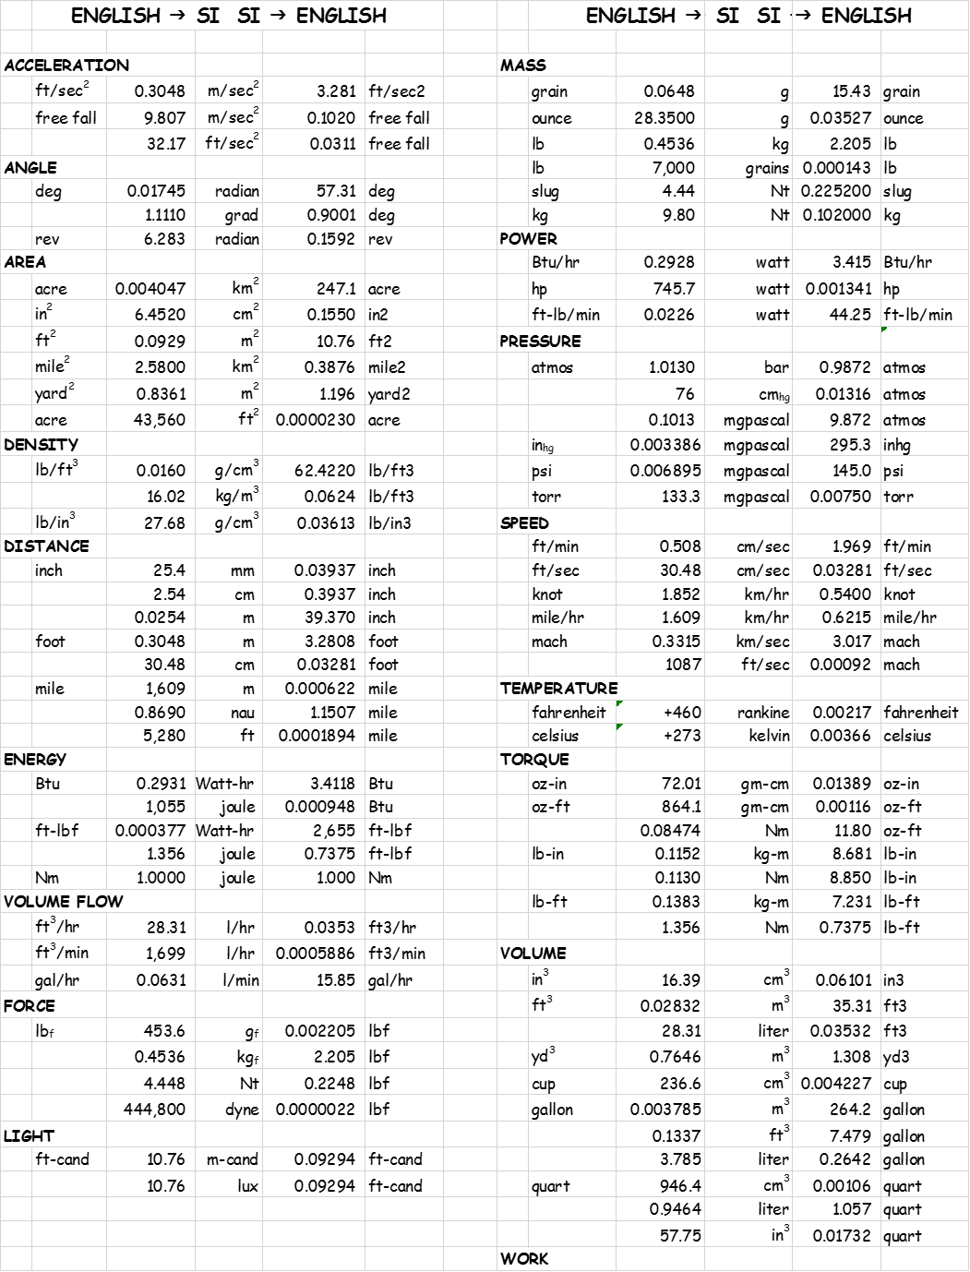

Heat Transfer Working Equations

| TYPE | FLOW / BOUNDARY | EQUATION | RESTRICTION |
| --- | --- | --- | --- |
| FORCED | EXTERNAL, FLAT PLATE, LAMINAR  AVG FILM COEFF | NuX = 0.332 Re0.5Pr0.333[1-(xO/x)3/4]-1/3  NuL = 0.664 Re0.5Pr0.333 | NuLOCAL  x0 UNHEATED LEN  PROPS @ TM  Pr > 0.6 |
| FORCED | EXTERNAL, FLAT PLATE, TURBULENT | NuX = 0.0292 Re0.5Pr0.333 | NuLOCAL  PROPS @ TM  Pr > 0.6 |
| FORCED | EXTERNAL, FLAT PLATE, TRANSITIONAL | NuL = 0.036 Pr0.333(ReL0.8-18,700) | NuAVERAGE  PROPS @ TM  Pr > 0.6  ReCRIT = 4.0 X105 |
| FORCED | EXTERNAL, FLAT PLATE,  TRANSITIONAL | NuX = 0.036 Pr0.333(ReL0.8 – 23,100) | NuAVERAGE  PROPS @ TM  Pr > 0.6  ReCRIT = 5.0 X105 |
| FORCED | INTERNAL, DUCT, LAMINAR | NuD = 1.86 [ReDPr(D/L)]0.333(μ/μW)0.14 | PROPS @ TB  EXC μW @ TW  Pr > 0.6 |
| FORCED | INTERNAL, DUCT, TURBULENT | NuD = 0.023 ReD0.8Prn  MCADAMS (DITTUS-BOELTER) | PROPS @ TB  0.7 < Pr < 100  n = 0.3 COOLING  n = 0.4 HEATING  |TW-TB| < 10OF LIQ  |TW –TB| <100OF GAS  FULLY DEV FLOW  Re > 10,000, L/D > 60 |
| FORCED | INTERNAL, DUCT,  TURBULENT | NuD = 0.023 ReD0.8Pr0.333(μ/μW)0.14  SIEDERT-TATE | PROPS @ TB  EXC μW @ TW  0.7 < Pr > 16,700  FULLY DEV FLOW  Re > 10,000, L/D > 60 |
| FORCED | INTERNAL, DUCT. TURBULENT | NuD = 5 + 0.025(RePr)0.8 | PROPS @ TB  LIQUID METALS  UWT  REDPR > 100  FULLY DEV L/D > 60 |
| FORCED | INTERNAL, DUCT, TURBULENT | NuD = 0.625(RePr)0.4 | PROPS @ TB  LIQUID METALS  UWHF  100 < REDPR < 10,000  L/D > 60 |

Transcribed from lecture notes from advanced heat transfer as a graduate student at Iowa State University.

Heat Transfer Working Equations (continued)

| TYPE | FLOW / BOUNDARY | EQUATION | RESTRICTION |
| --- | --- | --- | --- |
| FORCED | EXTERNAL SINGLE CYLINDERS | NuD = C(ReD)n   |  |  |  |  | | --- | --- | --- | --- | | ReD | C  GAS | C  LIQ | n | | 0.4-4 | 0.891 | 0.989Pr0.333 | 0.330 | | 4-40 | 0.821 | 0.911 “ | 0.385 | | 40-4000 | 0.615 | 0.683 “ | 0.466 | | 4000-40,000 | 0.174 | 0.193 “ | 0.618 | | 40,000-400,000 | 0.024 | 0.027 “ | 0.805 | | PROPS @ TM  C AND n FROM TABLE  CYL 90O TO FLOW |
| FORCED, HIGH SPEED FLOW | EXTERNAL, FLAT PLATES, LAMINAR | NuX* = 0.332 (ReD*)0.5(Pr*)0.333 | PROPS @ T*  PERFECT GASES  CONTINUUM FLOW  r = (PR)0.5 |
| EXTERNAL, FLAT PLATES TURBULENT | NuX* = 0.0292 (ReX*)0.8(Pr*)0.333  NuL* = 0.036 (ReL*)0.8(Pr*)0.333 | PROPS @ T*  PERFECT GASES  CONTINUUM FLOW  r = (PR)0.333  Re* ≤ 107 |
|  |  | PROP EVAL TEMP T*: M < 20  T* = 0.5(TS+TF) + 0.22(TR-TF)  r = (TR-TF)/( TO+TF)  TO = TF(1+((γ-1)/2)M2) |  |
| FORCED | LAMINAR, INTERNAL, FULLY DEVELOPED | NuCHF = 4.36  NuCWT = 3.66 |  |
| NATURAL | EXTERNAL, HORIZONTAL CYLINDERS | NuD = C(GrDPr)n   |  |  |  | | --- | --- | --- | | GrDPr | C | n | | 0-10-5 | 0.4 | 0 | | 10-5-104 | USE FIGURE | | | 104-109 | 0.53 | 0.25 | | 109-1012 | 0.13 | 0.333 | | PROPS @ TM*  EXCEPT β @ TF  C AND n F/TABLE |
| NATURAL | EXTERNAL, VERTICAL PLATES AND CYLINDERS | NuL = C(GrLPr)n   |  |  |  | | --- | --- | --- | | GrDPr | C | n | | 10-1-104 | USE FIGURE | | | 104-109 | 0.555 | 0.25 | | 109-1012 | 0.13 | 0.333 | | PROPS @ TM*  EXCEPT  @ TF  C AND n F/TABLE  *TM = ARITHMETIC MEAN WALL TEMP |

**Appendix 4 – Thermodynamic Properties**

**REFRIGERANT**

The refrigerant of choice is R134a. It is selected because it is readily available, has excellent properties, proven compatible components are plentiful, capable knowledgeable, safe service is readily available.

Physical Properties

Chemical Formula CH2FCF3 Molecular Weight 102.03

Boiling Point (1 atm) -14.9 OF -26.06 OC

Critical Temperature 213.9 OF 101.08 OC

Critical Pressure 588.9 psia 4060.3 kPa [abs]

Critical Density 32.17 lb/ft3 515.3 kg/m3

Decomposition Temp 482 OF 250 OC

Byproducts hydrogen fluoride carbonyl halides

Ozone depletion potential insignificant (ozone layer),

global warming potential significant (GWP100 = 1300)

acidification potential negligible (acid rain). 1,1,1,2-

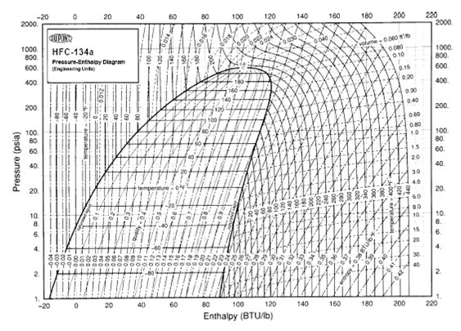

Figure A4-1: The P-h Diagram is the key thermodynamic chart for all refrigeration work. It directly shows cycle and capacity. From it all the needed parameters to describe a refrigeration cycle may be calculated.

Table A4-1: Thermophysical Properties of R134a



Transcribed from DuPont Suva; Thermodynamic Properties of HFC-134a; Technical Informtion, T134a ENG; ©E.I. du Pont de Nemours and Company

Figure A4-2 Moody Diagram of Friction Factors for Air

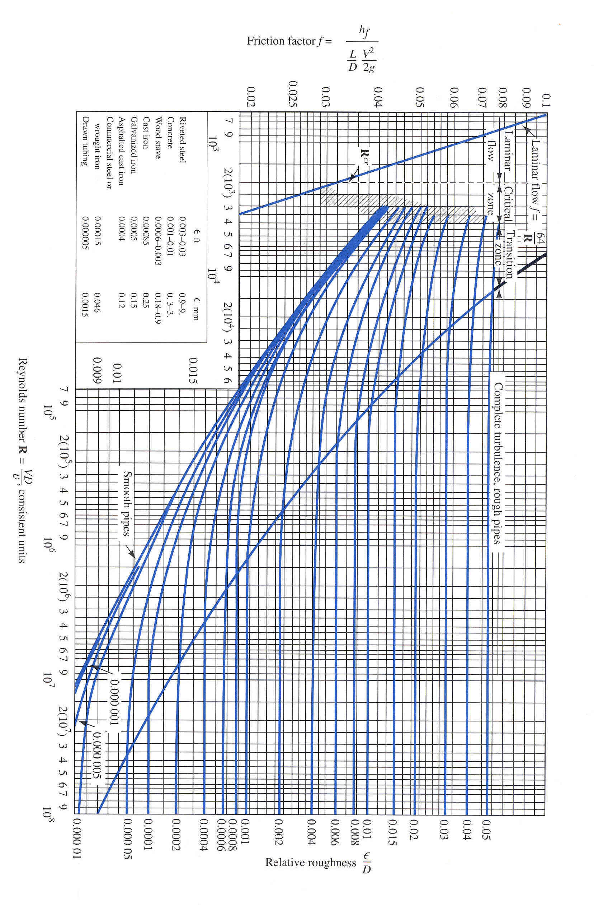

**Table A4-2: Thermophysical Properties of Air**

To be added

Appendix 5 – Psychrometric Properties

This Appendix shares the Psychrometric properties of water in air. There is some discussion of typical calculations performed with states, processes and cycles. There is also a brief discussion of the transient nature of cycles in a Heat Pump Dryer.

This is an “Extended” Psychrometric Chart available by searching “Psychrometric Chart English Units” on the internet. There are many other Psych charts available in both English and SI units. If you are a member of ASHRAE or have access to their references you may use the charts in their handbooks though they will not cover the temperature ranges needed for dryer psychrometric cycles. Or, you can purchase a program such as PsyCalc from ……Software for approximately $50 for a single seat license. ASHRAE also offers psychrometric software. These available software packages have the capability of mapping state points, processes and cycles as well as generating extended psychrometric charts as shown below.

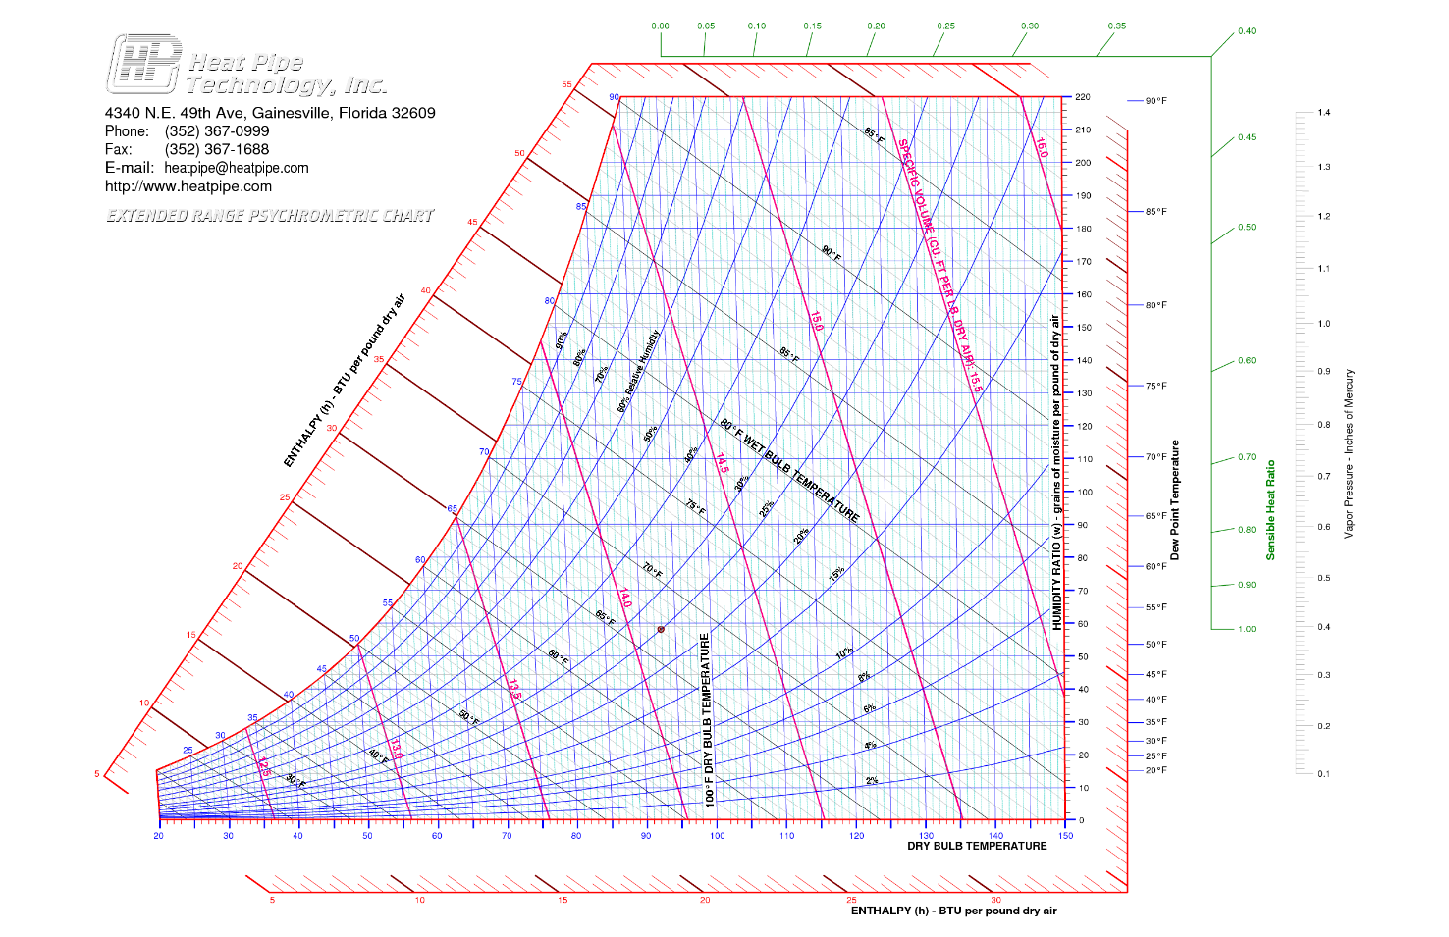

Figure XX: Extended Psychrometric chart for use in design of Heat Pump Dryers. The horizontal or sensible temperature axis is extended to 150OF. 180OF would be a better range extension but must be calculated using a commercially available psychrometric plotting utility.

Table A5-1 Themophysical Properties of Saturated Water



The data in this table is presented at 10 degree increments. It is available in 1 degree increments on the web and in various reference works. They can also be calculated at any increment using NIST’s RefProp program available from NIST for $100.

Appendix 6 – Simulation

Level 1 Simulation

Level 1 simulation involves the basic load conversion to required capacity and matching the capacity of a compressor to the required capacity. It is possible to manipulate this simulation to calculate capacity from required capacity and time requirements or any other manipulation of the dependent and independent variables. There is a significant user assumption on the effectiveness of the heat conversion to the load. This assumption takes the form of a correlation or “fudge factor” and can be quite large. It is discussed below in some detail so that the engineer can use some windage in setting the value.

|  |  |
| --- | --- |
| Key elements | Development |
|  | **Level I Simulation**  The objective in level I simulation is to write the basic first law energy balance and scope desirable combinations of compressor capacity, system state points and system performance factors.  The load is expressed as explained in “The Load” section of the design guide.  The load is met by capacity times time to dry.  The latent load is the primary objective of the clothes drying. That is, phase change of the water in the cloth into steam so that it can be removed by convection. In the heat pump dryer it is then re-condensed in an evaporator for removal by gravity or pump.    The sensible load is the heat required to lift the combined cloth and water to the temperature where the preponderance of evaporation takes place. We will call this the bulk temperature and it is largely the condensing temperature of the refrigeration system minus the temperature gradient necessary to flow heat from the heated supply air to the cloth.    Of interest is the temperature gradient necessary for heat transfer to the cloth. For purposes of stage I simulation it will be assumed to be 20 degrees. It will be left to stage II simulation to have an analytical means, supported by experimental observation, to quantify it.  Since every test dry cycle starts from a condition at equilibrium with the ambient and significant “lift” is necessary to bring the whole load up to the constant rate drying stage the dry cycle may be considered heavily transient. So the sensible load does not occur completely at condensing minus gradient temperature. Indeed some evaporation occurs well before the long term steady state drying temperature of the load occurs.  It has been observed that the startup transient in load temperature is often as high as a quarter or a third of the total cycle length. It is then reasonable to assume that only 2/3rds to 3/4ths of the temperature difference averaged over the whole cycle length is the effective sensible temperature difference.  With this observation the sensible load calculation becomes:      For purposes of time to dry, the usual assumption is that sensible load must be satisfied before the latent load. But, this is not entirely true since the surfaces may begin to evaporate before the cores of cloth or the core of the mass of clothes reaches evaporating temperature.  In fact, it is unknown at what temperature any molecule of water changes phase except that evaporation seems to occur at bulk temperatures well below the boiling point. Obviously the partial pressure of water vapor over the liquid layer plays a role. The only constant is that on a microscopic level to break the bonds of surface tension and escape as a molecule of water vapor the molecule must have been excited by energy equivalent to the heat of vaporization for a single molecule.  Thus for calculation purposes in the stage I simulation the infusion of sensible and latent heat are considered simultaneous rather than sequential and the rate of consumption equal to the total of the two and the rate of evaporation or drying equal only to the consumed portion of latent.  **The Heat Engine – the Compressor**  The heat engine is actually a heat pump operating on a vapor compression (VC) refrigeration cycle. For stage I simulation we will use the calorimeter capacity and watts to model the performance of the whole system. In Stage II simulation we will actually provide models of heat exchangers and expansion devices and potentially even modifications to the simple VC cycle. But for this stage we will not.  Airflow will be considered sufficient to make the whole calculated capacity available.  Additional lift of auxiliary heating will be considered in stage II but neglected here. That is, there will be no assumed increase in hot air supply temperature over the course of the dry cycle in stage I simulation.  Thus the low side enthalpy change of the calorimeter cycle represents the cooling or water condensing capacity of the heat engine.    For the heating side the low side enthalpy change plus power consumption of the compressor represent the heating capacity of the heat engine.    [In this work special compressor regressions were performed using pressures instead of temperatures since the compressor is a mass flow device and therefore driven primarily by pressure rather than temperature. For a complete discussion see the appendix titled compressors and compressor data.]  **Auxiliary Loads**  In order to operate a heat pump dryer there are number of auxiliary loads. A blower is necessary to move the air. If an auxiliary heater is used to boost the cycle state points and shorten the start transient this is an auxiliary load. Obviously the drum drive and controls represent additional loads. These auxiliary electrical loads must be totaled into the electrical consumption of the unit.    Since the auxiliary loads operate on different duty cycles each may be represented by an equation having the watts times elapsed time of operation as shown above.  At least two of the auxiliary loads above have a component of heating that adds to the heating capacity. In Stage I simulation that contribution to heating will be neglected. Those contributions will be deferred to Stage II simulation.  **Loss Factors**  Now the application of heat to the load is not complete. In conventional, even condensing dryers there is some significant loss of heat energy due to leakage, bypass and sensible heating of the dryer parts. While every attempt will be made control the loss of heat, some will occur.  There is obviously the mass of the unit to consider. Especially the drum, ducts, heat exchangers and the load itself. As the heating is gradual throughout the drying cycle, these losses may be considered simply a loss to net applied capacity or lumped.  More serious and yet more amenable to engineered improvement are bypass, and leakage losses.  Bypass is the occurrence of heated or energy laden air to simply blow by the load and impart no heat to the load. What is then lost by convection to the rest of the system in recirculation is a loss driven by greater energy intensity of the post load air flow.  Leakage losses take two forms. First is the physical leakage of air from the system at the high pressure seals of the supply side of the drum. This exfiltration of high energy heated air diminishes the energy and heating potential of the system. Conversely at the low pressure seals at the far side of the drum and in the connecting ductwork to the evaporator allow infiltration of low energy ambient air into the system. This low energy air must be brought up to the desired state points by additional load on the heat engine not related to the object load.  The second leakage is the convection/conduction losses through the walls to the ambient air. The moving drum ensures the wall losses are convective rather than natural. The velocities can be quite high.  In Stage II simulation these loss factors will be modeled in some detail. However in stage 1 they will simply be represented by two simple factors, arbitrarily set.  The first occurs in the drum and is called the drying effectiveness. Mathematically it represents the proportion of heating capacity supplied to the drum that ultimately causes evaporation.  The second is the condensing effectiveness. It represents the proportion of cooling capacity that is effective in condensing vapor into water at the evaporator.  Now the setting of these factors while arbitrary are not without scale. For instance when a simple comparison in conventional dryers is performed between the total energy supplied and the actual latent heat of water removed it is observed that about 50-55% of the total heating energy supplied is lost. This is excluding auxiliary power. So if attempts to seal and insulate are no more effective than today’s dryers, a 55% loss factor, or 45% effectiveness is reasonable. For Stage I study purposes ratcheting effectiveness factors in 5% steps as improvements in energy containment are considered may be a reasonable strategy for study.  The load of water to be removed is the same whether at the mass of cloth or from the air at the evaporator. So the maximum time taken by evaporation or condensation represents the time to dry.    **Performance Indicators**  There are three performance indicators that the Stage I simulation provides:   1. Time to dry (TTD) 2. Coefficient of Performance (COP) 3. Energy Factor (EF)   TTD is self-explanatory and is the maximum of the drying time of the drum or the condensation time at the evaporator.  COP is the ratio of desire benefit divided by the energy cost to achieve it. In the case of the heat pump dryer, it is the latent heat of vaporization of water from the wet cloth divided by the ET DRY. In order to dry the clothes they also had a sensible component of heating that is necessary for drying. But, ultimately if the water does not turn to vapor, no water removal can take place. So we do not count the sensible heat as part of the beneficial effect.  EF is the ratio of total energy used to dry the weight of dry cloth. |
|  |  |

Equations

Simulation flow chart

Level II Simulation

Whereas the Level I simulation was a simple capacity – load model, Level II simulation will include all the major system components and perform the necessary energy and mass balances.

All the parametric elements of the system are represented by lumped element models or nodes. The model includes all the three phases of drying; transient, constant rate and declining rate drying. Each phase is modeled in bulk or at the average point with start and end points or states assumed. Attainment of those intermediate state points is a control problem to be separately solved.

The refrigerant system is modeled with each of its principle components; compressor, expansion device, condenser and evaporator. Since it is vapor compression there will be a refrigerant on the hermetic side of the system and air on the external side of the system. In particular, since this is a dryer, wet air. For this reason the evaporator model must also model condensation or latent load.

The air side of the Phase II simulation is all the air side outside the refrigeration system. The drum will have an air mass, cloth mass, and drum mass nodes enclosed by an ambient node. The drum air mass exchange with the cloth mass will include both evaporation and convection heat and mass transfer models. Included in the air side model must be the air mover or blower and the auxiliary heating or duct heater. Filtration is also included but is modeled by a simple overall pressure drop. Fouling performance is initially neglected.

Level I simulation included a loss factor assumption. Level II simulation includes parametric model of the “Loss Factor” which affects the amount of heat actually escaping the system. It will include heat loss by convection, radiation with the surroundings and air exfiltration/infiltration with the surroundings.

This adds some complexity but forces consideration of all the major product performance elements.

|  |  |
| --- | --- |
| Key elements | Development |
|  | Level II Simulation  The Load  Phase II simulation begins with the load. Development of the load is by the same means as the Level I simulation. That is, latent and sensible loads are calculated. The appropriate assignment of loads are made to cloth and water appropriately. In order to use it in the Phase II simulation it must be converted from a simple number into state information for the node that represents the Cloth Mass Node. The loads are used in the simulation to provide reference for deciding dry cycle completion.  The model for the cloth mass node is shown in illustration PII-1.    Diagram PII-1: Cloth mass node model. The Node has mass and temperature for both water and dry cloth. Both receive heat from the air and drum. The node gives up mass to the air in the drum through evaporation and transpiration.  The cloth mass node has two components, cloth and water. Latent load is assigned to the water and sensible assigned to the cloth and the water. There must be a division of heat energy going to the water. Some of it will go to sensible heating of the water and some will naturally begin the evaporation process. While some of the energy will bypass the load completely.  This division is accomplished by keeping the water and cloth temperatures the same while assigning the rest to evaporation. But there is a limit to how much evaporation can take place. The remainder must go into sensible heating until the energy of the node is sufficient to drive all the heat absorbed into latent. The algorithm for this division is shown below followed by the equations to model it.    Allocation of energy to sensible, latent and bypass  For |

Equations

Simulation Flow Chart

Level III Simulation

Level III simulation converts the level II parametric simulation into rate equations and constructs a first principles transient simulation of the cycle performance.

|  |  |  |  |
| --- | --- | --- | --- |
| Essentials | Background | | |
|  |  | | |
| The one dimensional basic energy equation for a node is shown below. It contains the energy flows on the left side with the generation term. On the right side is the expression of nodal energy. In particular its change over the time step.    Inverting the equation and solving for the new temperature at the end of the time step gives the following form.    While the difference equation is complete mathematically as stated, it does not resolve the units for normally stated parameters. Using the units for catalog or table values of the variables and resolving the units the equation is dimensional correct stated as follows for English units:    This form of the equation applies to every node with some terms dropping out for the special conditions of no generation or boundary nodes. It is also possible to solve the combined convection/conduction condition in the final outside shell and substitute the more complete statement in the equation. The alternative is to simply neglect the convection and assume constant wall temperature.  This equation can be programmed in its various forms in a simulation tool such as Excel or PsiLab. To simulate the heat pump dryer coming up to full capacity a time based function can be provided for the outer air or nodal temperature. | | | |
|  | | | To utilize these equations in simulation |
|  | | |  |

Equations

Simulation Flow Chart

Appendix 1 – Glossary

This is a listing of variables used and units

| Var | Name | Units | Var | Name | Units |
| --- | --- | --- | --- | --- | --- |
| T  cP  ρ  A  v  V  k  r  R  q  t  Δt  Thk  W | Temperature  Specific Heat  Density  Area  Velocity  Volume  Thermal conductivity  Radius  Heat flux  Time  Elapsed or difference in time  Thickness  Weight | OF  Btu/lbmOF  lbm/ft3  in2  in3  Btu in/ft2OF  in  in  Btu/hr  sec  sec  in  lb | N  O  I  1  2 | Subscripts  Node  Outer node  (denotes general direction of heat flow)  Inner node  Beginning time or condition  Ending time or condition |  |

Nomenclature

W Weight of cloth

APPENDIX 2 CHARTS AND GRAPHS

CHART A2-1



CHART A2-1: Water weight in cloth. This table gives the weight of water in various bone dry weights as a function of the initial moisture content

GRAPH A2-1

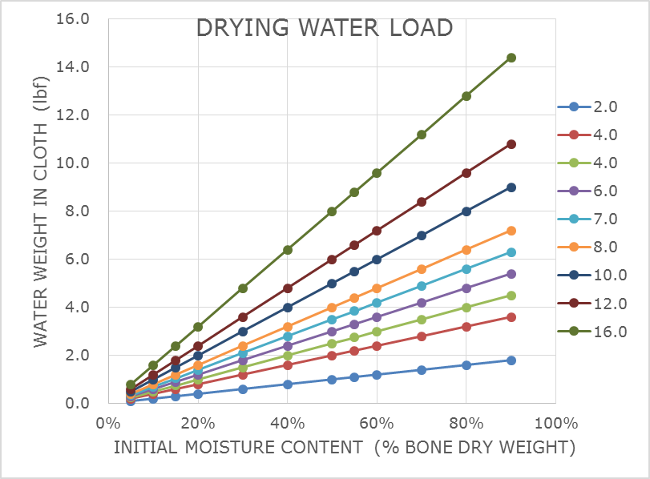

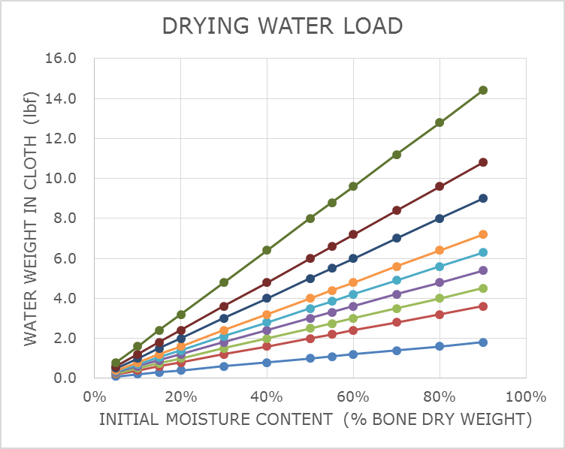

**Appendix 7: COMPRESSORS**

Compressor characterization; compressor models; manufacturer’s web sites; data download; data regression; compressor selection table.

A compressor is a mechanical device for transporting gas from an inlet port to an outlet port while raising the pressure of the gas. Because gas is compressed, it also heats up according to the work of raising its pressure. The capacity of the condenser is sized to match the load plus work of compression.

Since small and medium sized home appliances including air conditioners 5 tons or less are mass-produced and the sealed system checked at the factory, hermetic compressors are preferred. A hermetic compressor is a sealed unit with its only communication with the outside environment through its intake port, exhaust port, and any oil cooler or de-superheater ports. Normally the compressor, muffler, motor, suspension and connective tubing are sealed inside a steel clamshell by welding.

The device is powered by electrical energy through a connector called a fusite. The fusite is welded into a hole in one of the shells and the connectors potted to prevent leaks over the life of the compressor.

There are three prevalent types of compressor for home appliances. First is the reciprocating compressor, second the rotary compressor, and third the scroll compressor. The reciprocating compressor is a simple piston in cylinder compressor with two valves, one for inlet, one for discharge.

The compressor is thought of as an isentropic device. That is, it raises the pressure of a gas in a process that follows a line of constant entropy. This is true in an ideal system. But real compressors have friction, bypass or blow by, eddy currents and other small effects that decrease compression efficiency or add unrecoverable energy to the gas. Thus, entropy will increase slightly during compression. The ratio of the isentropic process end point to the actual endpoint is the isentropic efficiency.

**Compressor Models**

There are four prevalent compressor models three of which are industry-wide accepted modeling methods:

**Displacement Model:**

The displacement model basically is an in-cycle transient capable compressor simulation model. It uses the displacement of the compressor along with isentropic efficiency and speed to act on input properties to produce estimates of output properties. Its primary output is mass flow. The following equation set forms the basic model.

**AHRI 10-point data model:**

The AHRI 10-point data model is essentially an nth order polynomial regression format adopted by AHRI for expression of capacity and watts vs. evaporating and condensing temperatures. Since a national/international standards organization is behind the model, most compressor manufacturers have coefficients for the model available in on-line websites or are available from the tech support group of the manufacturer. Writers of simulation or analysis software generally include a feature to use this data in analysis work.

The AHRI 10-point model is an nth order polynomial fit to the range of known data. As such it is not extensible and making extrapolations very risky as the behavior beyond the known range is not understood.

**GE 7 coefficient model:**

The GE 7 coefficient model is also an nth order polynomial regression format used by GE for expression of capacity and watts vs. evaporating and condensing temperatures. This model has recently been modified to a 6 coefficient model but remains an nth order polynomial. Coefficients are available maintained in a database on TechNet.

**Pressure Model**

The pressure model is a way in which experienced engineers look at compressor data. There are two problems with the nth order regression models. First they use no terms that are actually causative to desired performance. Second, the very nature of an nth order polynomial fit is that behavior outside the known range of data used for regression is completely unpredictable and therefore prohibits extrapolation.

The Pressure Model solves both of these problems. First the terms are the actual driving functions for flow in any fluids analysis, that is, pressures and pressure ratio. Second the resulting regression is monotonically increasing and therefore predictive and can be cautiously extrapolated within known limits of operation rather than only the range of data regressed. Because of these facts experienced analysts in refrigeration design sometimes take the time to create original regressions using the pressure model to perform their analyses.

Most refrigerant system modeling software has adopted the first two. GE stands alone with its compressor model. The pressure model is used by individual engineers in personal work.

These models are suitable for compiled language simulation. The models with coefficients are also suitable for spreadsheet applications for predicting performance in steady state models.

Since compressor modeling has traditionally come from academia into industry there is a penchant for nth order polynomials to be used to regress data. While the regressions can be forced to predict data quite accurately, they are risky to extrapolate since the behavior of the lines outside the data range is unknown beyond the basic characteristic of the line. All nth order polynomials have in general n-1 points of inflection. So, once you depart the range of known data, it is possible to describe the shape but not predict how fast divergence occurs.

In the case of the above cited models the 10 term and 7 term models are both nth order polynomials with limited correlation to physical phenomena of behavior. They will both give excellent predictions of performance over the range of known data.

The author prefers to have a model with reasonable extrapolation capability. This is best accomplished with a model that more closely approximates the actual physics of the case. In the case of compression, the compression process is a mass transfer or flow process. The intake of the compressor is flow through a port and intake valve. The exhaust is flow through a discharge valve and a port. Flow is motivated by pressure, not temperature. While we want to know about the temperatures of condensing and evaporating, these are heat exchange properties, not mass. While it is true that density is a property determined in vapor state by both temperature and pressure, it is the pressure difference that induces flow. Thus the author prefers to regress to pressures rather than temperatures. While the inlet condition ultimately determines the amount of gas taken in each gulp at the inlet it is the pressure difference that determines throughput. Thus the author prefers to use evaporating and pressure ratio as regression terms and condensing pressure is usually included. Thus the ratio term gives a slight curvature to the data but the data is monotonic as you would expect real data to be.

The real Y in a compressor is mass flow rate, not capacity. But real data is acquired in a compressor calorimeter where in order to obtain mass flow data the capacity is recorded under known saturation conditions and the mass flow rate calculated from the capacity. There will be some error in any use of data thus acquired.

**Manufacturer’s Web Sites**

All the major manufacturers of compressors globally have data for their production models posted on their corporate web sites. Some are more tricky to find than others but they are there. Data is different by manufacturer. In some cases enough data is shown in the website to go directly to a data analysis and regression. In other cases there may not be enough and a call to a manufacturer’s rep may be necessary.

www.acccompressors.com

www.embraco.com

www.panasonic.com

www.danfoss.com

www.tecumsehusa.com

**Manufacturer’s Data**

Manufacturer’s data is normally presented in tables of capacity and watts. The derived parameters of EER and Mass Flow if presented are simply products or quotients of the first two and the standard test conditions. Data are grouped into tables having condensing temperature on one axis and evaporating temperature on the other axis. A typical presentation of data is presented below.

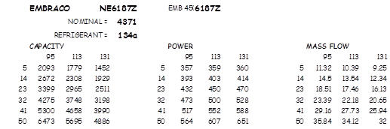

Table 1: Manufacturer’s data for Embraco NE6187E. Data is organized by type and with columns and rows for condensing temp and evaporating temp respectively.

Compressor Data Regression

When compressor data is accumulated it may be manipulated to yield a model suitable for simulation or analysis:

Step 1 Transfer the data into an EXCEL worksheet

Step 2 Stack the data organizing by evaporating temperature and then by condensing temperature (table 2).

Step 3 By reference to property data, convert temperatures to pressures if regression to pressures rather than temperatures is desired (table 2).

Step 4 In individual columns modify and combine temperatures or pressures alone or in combination to create the variables to consider in regression (table 2).

Step 5 Perform regression using “Tools >> Data analysis >> Regression and filling in the appropriate selections.

Step 6 Analyze the output for significance of terms and determine if factors should be omitted or included (table 3).

Step 7 Repeat until significance is attained and Watts are also regressed.

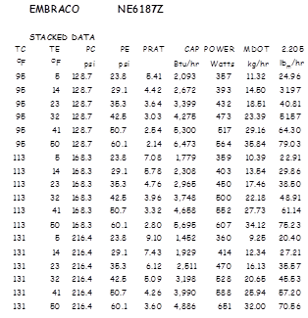

Table A7-2: Stacked data for Embraco NE6187E ready for input into regression utility. Note temperatures converted to pressures and the insertion of “PRAT” (pressure ratio) to feed the regression.

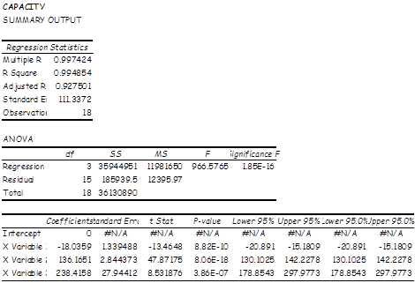

Table 3: Regression analysis. Note the coefficients, p-values of coefficients and R-squared. This regression is an excellent representation of the data.

The following table lists variables and other considerations for all of the standard models.

**Compressor Selection Table**

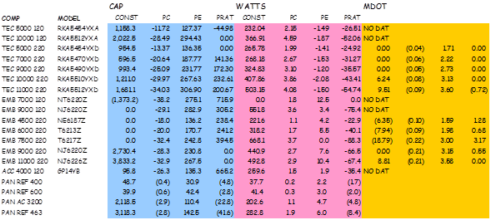

Recently added models



Once the regressions have been performed and the results cataloged in table form the analyst can embed the table along with a property conversion worksheet in a simulation, analysis or create a stand alone compressor evaluation program to assist them in their work.

**Extrapolation of Data**

While the nth order polynomials may not be suitable for extrapolation, lower order models are continuous and predictable in an extrapolation. One must be aware that errors in range are multiplied out of range. Therefore one should anticipate these errors affecting further analysis.

The heat pump dryer is a case in point. In order to multiply system capacity system parameters have been selected outside the normal operating range of all suppliers compressors. Rather than burden compressor suppliers with significant additional testing for an uncertain application, regression equations were extrapolated significantly outside the range of tested performance. The values of capacity and watts thus obtained were used in simulation, coil sizing and other important calculations. Two methods were used to estimate the potential size of errors generated by this extrapolation.

**Confidence band method**

Where actual compressor data is somewhat noisy the regressed performance equations generate statistics with which a confidence band can be drawn indicating that there is a band within which the true performance line may lay. Use of this method allows the analyst to estimate the potential size of an error but not the direction of that error.

**Alternate regression method**

This method relies on a referee regression having equal or better fit to the known data and comparing the predicted values in the desired range of application. It has been discovered that this method is actually very good. The result gives not only estimate of error but also the direction of that error. In our case the alternate regression was a simple 2nd order polynomial trend line on a known condensing temperature line when the data is plotted against evaporating temp or pressure.

When the design was matured enough to narrow in on the compressor that should actually be applied, request was made to the compressor supplier to run data in the application range. That data when plotted allowed us to refine our simulations and analyses and make more confident projections of performance.

The methods above are illustrated in the following figures.

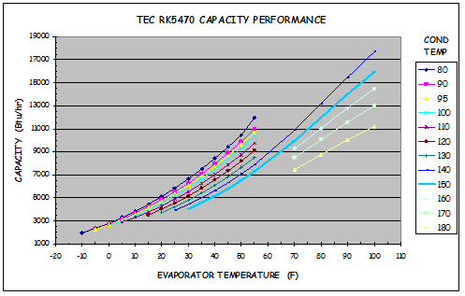

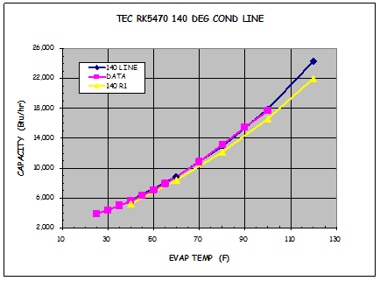

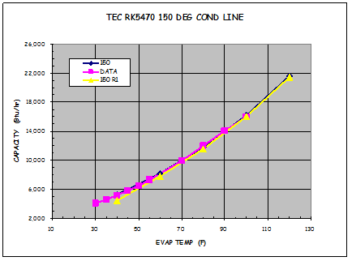

Thus it can be seen that the pressure method yields excellent agreement with calorimeter measurements.

1. Most of “The Lint” was provided in the rotation report and Green Belt Project of Cathryn Vermeersh in the summer of 2013.
2. One ton of cooling power is the amount of heat necessary to melt one ton of ice at 32OF in 24 hours or 12,000 Btu/hr or 3.517 kW.